FLayRate: AN OFFLINE EMBEDDED WEB-BASED MONITORING
AND FORECASTING SYSTEM FOR LAYER CHICKEN EGG PRODUCTION

John Eduard De Villa
Hanns Christian Donor
Felman Eleponga

Bachelor of Science in Information Technology
2026
LayRate: AN OFFLINE EMBEDDED WEB-BASED MONITORING
AND FORECASTING SYSTEM FOR LAYER CHICKEN EGG PRODUCTION

A Capstone Project
presented to
The Faculty Committee of the College of Informatics and Computing Sciences
Batangas State University
The National Engineering University
ARASOF – Nasugbu Campus
In partial fulfillment
of the requirements of the degree
Bachelor of Science in Information Technology
Business Analytics Track

By
John Eduard De Villa
Hanns Christian Donor
Felman Eleponga
2026
TABLE OF CONTENTS
Chapter Page
I. THE PROBLEM AND ITS BACKGROUND 8
Introduction 8
Background of the Study 12
Objectives of the Study 14
Significance of the Study 17
Scope and Limitation of the Study 18
Definition of Terms 23
II. REVIEW OF LITERATURE AND STUDIES 29
Conceptual Literature 29
Research Literature 35
Technical Background 41
Theoretical Framework 46
Conceptual Framework 50
Synthesis 54
III. DESIGN AND METHODOLOGY 59
Research Design and Methods 59
Design Stage of the Process 65
Planning Phase 67
Designing Phase 69
Development Phase 71
Testing Phase 72
Deployment Phase 73
Development Process 74
Testing Process 74
Debugging Process 75
Validation Process 75
Programming Procedure 76
System Architecture 76
Forcasting Models 79
Physical Network Setup Diagram 81
Schematic Diagram 85
Requirements Analysis 89
Use Case Diagram 91
Context Diagram 93
Data Flow Diagram 94
Entity Relationship Diagram 96
Software and Hardware Needed in the Development 98
Software Requirements 98
Hardware Requirements 101
Instrumentation 104
Preparation and Evaluation 115
Ethical Considerations 119
References 121

LIST OF TABLES
Table Page
I Software Needed in the Development 97
II Hardware Needed in the Development 100
III Benchmarking Tools and Corresponding Metrics per Evaluation Area 106
IV System Functionality Evaluation Criteria for LayRate 115
V Guideline Interval for Performance Rating Scale 117

LIST OF FIGURES
Figure Page
1 Theoretical Framework of the Study 46
2 Conceptual Framework of the Study 52
3 Agile Methodology 65
4 System Architecture of LayRate 76
5 Forecasting Model of LayRate 78
6 Physical Network Setup Diagram of LayRate 80
7 Schematic Diagram of LayRate 84
8 Requirements Analysis of LayRate 88
9 Use Case Diagram of LayRate 90
10 Context Diagram of LayRate 92
11 Data Flow Diagram of LayRate 93
12 Entity Relationship Diagram 95
CHAPTER I
THE PROBLEM AND ITS BACKGROUND

INTRODUCTION

Agriculture plays a central role in the Philippine economy, providing food security, rural employment, and national development opportunities. Within this sector, poultry production, particularly layer hen farming, is a vital source of affordable and accessible protein for the population [1]. Eggs are one of the most widely consumed and nutritionally complete food commodities, making the productivity and stability of layer egg production critical not only for farm operators but also for the broader food supply chain.

Despite its importance, many Philippine layer farms — especially small- and medium-scale operations continue to rely on manual, paper-based methods for recording daily egg production [2]. Under PSA Board Resolution No. 04 (2022), layer hen farms raising 250 birds and below are classified as smallhold, while those raising 251 to 5,000 birds are semi-commercial, meaning the vast majority of layer operations fall outside the large commercial scale [50] where automated management systems are typically adopted. Despite this fragmented farm structure, the hen egg subsector remains productive, reaching 201,600 metric tons in the first quarter of 2025 alone a 12.1% increase year-on-year [51] underscoring how much food security depends on sound production management even at the smallest farm level. Yet despite this productivity, production management practices at the farm level remain inadequate. Some farm operators do not record daily egg counts at all; instead, they often rely on the number of trays produced per day as a rough indicator of output. This practice provides no reliable basis for tracking performance trends, detecting production anomalies, or making timely, data-driven management decisions on culling, restocking, or feed adjustment.

Effective layer farm management requires more than recording egg counts it demands continuous visibility into all variables that influence flock productivity, and the ability to act on that data automatically when conditions threaten performance. Mortality rates, daily feed intake and its crude protein content, and environmental conditions such as temperature and humidity inside poultry houses are known to directly affect flock health and laying performance, yet monitoring and control of these variables is often inconsistent or entirely absent in small- to medium-scale Philippine farms. Heat stress in particular is a persistent and measurable productivity threat in tropical farm environments, reducing feed intake and laying rate when left unmanaged. Without structured, automated collection and response to these management variables, farm operators cannot establish the data foundation needed to understand production trends, diagnose performance problems, or protect flock productivity in real time. LayRate addresses this gap by providing an integrated farm management platform that automatically collects egg counts through IR break beam sensors, continuously captures temperature and humidity through DHT22 sensors without requiring any manual environmental recording, automatically activates a cooling fan through a relay module when temperature inside the coop exceeds a defined threshold to mitigate heat stress, logs feed consumption and crude protein intake, tracks mortality, and generates production forecasts giving farm operators both the data visibility and the automated environmental control needed for complete, proactive layer farm management.

Digital and IoT-based tools have demonstrated clear benefits in poultry farm management, enabling data-driven oversight of production and environmental conditions [2], [3]. Forecasting future egg production using accumulated data further supports farm operators by enabling proactive management decisions — anticipating production declines before they occur and informing timely action on culling schedules, restocking, and feed management. However, adoption of these technologies in the Philippines has been limited. Factors such as high cost, technical complexity, and inconsistent internet connectivity in rural areas have prevented many farms from implementing modern digital management solutions. As a result, Philippine layer farms often operate without integrated monitoring or forecasting systems, leaving farm operators unable to manage their flocks with the precision, timeliness, and data confidence that modern layer production demands.

To address these challenges, this study will develop LayRate: An Offline Embedded Web-Based Monitoring and Forecasting System for Layer Chicken Egg Production. LayRate is a locally hosted farm management platform to be deployed on an embedded computing device within the farm, accessible through a browser connected to the local network. Designed as a complete management tool rather than a simple data recorder, LayRate equips farm operators with automated egg production tracking, continuous environmental monitoring through DHT22 sensors, automated temperature-based cooling fan control through a relay module to protect flocks from heat stress, structured feed and nutrition logging, mortality recording, and machine learning-based production forecasting. By combining these management functions including both passive data collection and active environmental response in a single offline-capable platform, LayRate provides farm operators with the data visibility, automated control, and predictive insights needed for timely, evidence-based decisions on feed management, flock health, culling, and restocking.

The system aims to transform the way small- and medium-scale Philippine layer farms are managed shifting from experience-based guesswork to structured, data-driven decision-making. By delivering an integrated, easy-to-use management platform that functions without internet connectivity, LayRate addresses both the technological and infrastructural barriers that have historically prevented Philippine layer farms from adopting digital management tools, demonstrating a contextually appropriate path toward precision poultry farm management.

BACKGROUND OF THE STUDY

Layer hen farming in rural areas of the Philippines, such as Nasugbu, Batangas, often relies heavily on manual labor for daily operations. Based on an informal inquiry with a medium-scale poultry farm owner in this area, egg collection and production monitoring are performed manually. The farm relies on visual inspection of eggs in trays and manual counting, without the use of digital tools, IoT systems, or production analytics. The owner indicated that these practices were eventually discontinued months ago. Consequently, there is no systematic recording of egg production, no ability to track overall hen performance, and no feedback mechanisms to inform farm management decisions.

A critical challenge is the absence of data: there is no record of whether hens meet weekly production quotas, and no historical data exists to support analysis or informed decision-making. This lack of structured data prevents farm owners from understanding production trends, identifying underperforming hens, or optimizing feeding and management practices.

Existing practices highlight a significant gap in farm management: small- to medium-scale poultry farms lack accessible, low-cost, and integrated tools that can monitor production in real time, provide analytics, and assist in forecasting egg output.

This context underscores the need for a system like LayRate: An Offline Embedded Web-Based Monitoring and Forecasting System for Layer Chicken Egg Production, which aims to provide automated data collection, real-time monitoring, and predictive insights tailored to the operational realities of Philippine farms. By addressing these gaps, the proposed system will serve as the foundation for more efficient, data-driven poultry farm management.

OBJECTIVES OF THE STUDY

The main objective of the study is to develop LayRate: An Offline Embedded Web-Based Monitoring and Forecasting System for Layer Chicken Egg Production a fully integrated, offline farm management platform hosted on a Raspberry Pi that equips small- to medium-scale layer farm operators in the Philippines with automated production monitoring, continuous environmental data collection, automated temperature-based cooling fan control, nutritional tracking, and data-driven egg production forecasting to support timely and informed farm management decisions.

Specifically, the study aims to:

1. Identify the features to be incorporated in LayRate to effectively address the management challenges encountered by layer farm operators in egg production monitoring, environmental oversight, nutritional tracking, and data-driven decision-making inside the poultry coop.

2. Develop the core management modules of LayRate to automate and integrate the following farm management functions:
2.1. Egg Production Forecasting generation of production forecasts using XGBoost regression as the primary model, with SARIMA as a baseline comparison, utilizing feed consumption, crude protein level, breed, mortality, flock age, and environmental inputs as forecasting variables to support proactive farm management decisions;
2.2. Hen-Day Egg Production (HDEP) Computation automatic calculation and tracking of daily laying rate per cage from recorded egg counts, providing a standardized production performance metric for trend analysis and management review;
2.3. Environmental Data Logging continuous and automated collection and storage of temperature and humidity readings from DHT22 sensors, requiring no manual environmental recording by farm operators; and
2.4. Automated Egg Counting automated detection and tallying of eggs per cage using IR break beam sensors, eliminating manual counting as a prerequisite for production record-keeping; and
2.5. Automated Environmental Control automatic activation of a cooling fan through a relay module when the temperature inside the poultry coop exceeds a defined threshold, reducing heat stress on the flock without requiring manual intervention by farm operators.

3. Evaluate the accuracy of the Egg Production Forecasting Module against actual recorded egg production data in terms of:
3.1. Mean Absolute Error (MAE);
3.2. Root Mean Square Error (RMSE);
3.3. Mean Absolute Percentage Error (MAPE); and
3.4. Comparative model performance between XGBoost regression and SARIMA.

4. Measure the performance efficiency of the developed system using benchmarking tools, specifically in terms of:
4.1. Response Time;
4.2. Throughput;
4.3. Scalability; and
4.4. Reliability under Load.

SIGNIFICANCE OF THE STUDY

The success of the study was deemed beneficial to the following individuals or groups.

Batangas State University – TNEU ARASOF Nasugbu. Demonstrates the application of technology in agriculture, serving as a model for future IT and agricultural projects.

College of Informatics and Computer Sciences. Provides a reference for students and faculty on integrating IoT, data analytics, and predictive modeling in real-world systems.

Client / Participating Farm Owner. Gains automated egg production monitoring, nutritional tracking, and predictive insights, enabling data-driven farm management.

Small to Medium-Scale Poultry Farm Owners & Workers. Improves production efficiency, reduces manual monitoring, and frees workers to focus on higher-value tasks.

Agricultural Agencies and Extension Services. Offers structured farm data to support planning, policies, and targeted assistance for smallholder farms.

Future Researchers. Supplies a framework and dataset for precision poultry farming, IoT integration, and predictive analytics studies.

Local Communities. Enhances egg production consistency, indirectly supporting food security and rural income stability in areas like Nasugbu, Batangas.

SCOPE AND LIMITATION OF THE STUDY

This study will focus on the development and implementation of LayRate: An Offline Embedded Web-Based Monitoring and Forecasting System for Layer Chicken Egg Production. The system will be designed to automate egg production monitoring, track and actively respond to environmental conditions inside poultry coops, and record daily feed intake and crude protein content of the feeds, while also generating production forecasts to support data-driven management decisions for layer farm operators. It will allow operators to record daily egg counts, automatically calculate Hen-Day Egg Production (HDEP), monitor temperature and humidity using DHT22 sensors, automatically activate a cooling fan through a relay module connected to the Arduino Uno R3 when the measured temperature inside the coop exceeds a configurable threshold — mitigating heat stress on the flock without manual intervention — input the specific breed of the layer flock per cage through a predefined breed selection interface, and input feed data for tracking consumption and nutrient composition; mortality will also be considered. Historical production, environmental, feed, mortality, and breed data will be stored in a local database, which will provide visual dashboards and reports to display trends and forecasted production. The system will be accessible through Brave, Chrome, and Safari web browsers connected to the farm's local network, enabling operators to track flock performance without requiring internet connectivity. Automated alerts will notify the operator of abnormal production patterns, environmental conditions, or unusual feed intake trends that may affect flock performance. Lastly, it will be optimized for desktop browser access, with mobile browser compatibility.

The production forecasting module will be implemented using XGBoost in regression mode as the primary predictive model, with SARIMA serving as a baseline comparison model. XGBoost will generate egg production forecasts using daily feed consumption, dietary crude protein content, temperature, humidity, flock age, and breed, mortality as input variables, while SARIMA will forecast production trends based on historical HDEP time-series data alone. Forecasting accuracy will be evaluated using Mean Absolute Error (MAE), Root Mean Square Error (RMSE), and Mean Absolute Percentage Error (MAPE) to produce a measurable, quantitative assessment of the module's predictive performance. Both models will be executed locally on the Raspberry Pi 4 Model B using Python, ensuring full forecasting functionality without requiring internet connectivity.

However, the study has limitations. LayRate will be designed for offline operation only and will not support cloud-based remote access or synchronization with other systems. Environmental monitoring and automated cooling fan control will be limited to temperature and humidity as the triggering variable; other environmental factors such as light intensity, ammonia levels, or feed wastage will not be monitored or controlled. The automated cooling fan will respond only to temperature thresholds and will not regulate humidity, ventilation rate, or other environmental parameters. Production forecasting will rely solely on recorded historical production, feed, environmental, mortality, and breed data, and will not predict unexpected events such as disease outbreaks, equipment failures, or sudden changes in feed availability.

Both the XGBoost and SARIMA forecasting models are subject to the cold start limitation, a common and expected characteristic of machine learning-based forecasting systems wherein models require a sufficient volume of historical data before reliable predictions can be generated. During the initial deployment period, LayRate will operate solely as a monitoring and data collection platform, and forecasting functionality will only become available once enough historical records have been accumulated. SARIMA, as a univariate time-series model that relies exclusively on historical HDEP data, is particularly sensitive to data scarcity and requires a minimum of approximately 50 observations, with more than 100 preferred, before its forecasts can be considered statistically reliable. XGBoost, while demonstrated by Bumanis et al. [6] to perform well under limited dataset conditions relative to other machine learning models, still requires a baseline volume of complete daily records across all input variables — feed consumption, crude protein, temperature, humidity, flock age, breed, and mortality — to generate meaningful predictions. To address this cold start limitation, the researchers requested the participating farm owner to record at least three months of production data prior to model training, providing a minimum baseline dataset for initial forecasting.

The forecasting module's accuracy is likewise expected to improve progressively as more historical data is accumulated over time, and predictions generated during the early deployment period should be interpreted with appropriate caution. Additionally, since SARIMA forecasts are based solely on historical HDEP patterns without incorporating feed, environmental, mortality or breed variables, its predictive accuracy may be lower than XGBoost under conditions where those variables significantly influence egg production trends.

The system will be intended for farm operator use only, with no support for third-party access or multi-farm integration. Data storage will be constrained by the embedded device's memory capacity, requiring manual management of backups and archiving for long-term records. Additionally, the system will not include advanced artificial intelligence for anomaly detection or automatic control of feeding, water, or environmental systems. The forecasting module will not incorporate LSTM-based deep learning models in this iteration, as such architectures require substantially larger sequential datasets than are available during initial deployment on small- to medium-scale farms; LSTM integration is reserved as a direction for future development once sufficient longitudinal data has been accumulated. Finally, while the system will be deployed and tested in a specific farm, LayRate will be designed to be flexible and adaptable, making it suitable for other layer farm operations with different flock sizes, management practices, feed formulations, mortality, breed compositions, and environmental conditions.

DEFINITION OF TERMS

Arduino Uno R3. This term refers to the open-source microcontroller board used in LayRate as the primary data acquisition and control unit that interfaces with the DHT22 sensor, IR Break Beam sensors, and relay module to collect temperature, humidity, and egg count readings and to activate the cooling fan when temperature thresholds are exceeded, transmitting all collected data to the Raspberry Pi 4 Model B for local processing and storage.

Coop. This term refers to the physical building or enclosed facility that houses the Layer Cages within a layer farm, serving in this study as the primary environment where the Layer Hens are kept and managed, and within which all production monitoring, environmental data collection, and automated cooling control activities of the LayRate system are conducted.

Cooling Fan. This term refers to the electric fan connected to the Arduino Uno R3 through a relay module in LayRate, which is automatically activated when the temperature inside the poultry coop exceeds a defined threshold, providing automated cooling to reduce heat stress on the layer flock without requiring manual intervention by farm operators.

Crude Protein (CP). This term refers to the estimated protein content of a feed batch expressed as a percentage, entered into LayRate per feed record and used alongside feed consumption as a nutritional input variable for forecasting egg production performance.

DHT22 Sensor. This term refers to the digital temperature and humidity sensor used in LayRate that is connected to the Arduino Uno R3 to continuously and automatically measure the environmental conditions inside the Layer Hen housing, providing data used for production monitoring and analysis without requiring manual environmental recording by farm operators.

Edge Computing. This term refers to the data processing approach used in LayRate wherein all sensing, storage, analytics, and forecasting operations are performed locally on the Raspberry Pi 4 Model B rather than on a remote cloud server, enabling full system functionality in farm environments with limited or no internet connectivity.

Embedded System. This term refers to the hardware component of LayRate consisting of the Arduino Uno R3 microcontroller, connected sensors, and relay module that are physically integrated within the Layer Hen housing environment to automatically and continuously collect egg count, temperature, and humidity data, and to activate the cooling fan when environmental thresholds are exceeded, all without human intervention.

Feed Consumption. This term refers to the total amount of feed consumed by hens per cage on a daily basis, recorded through the LayRate web application and used as a primary input variable in the system's egg production forecasting module alongside mortality, breed, crude protein level, environmental conditions, and flock age.

Forecasting. This term refers to the process used in LayRate of applying two complementary predictive models — XGBoost in regression mode as the primary forecasting algorithm, and SARIMA as a baseline comparison model — to historical egg production, feed consumption, dietary crude protein, temperature, humidity, flock age, mortality and breed data in order to generate quantitative estimates of future Hen-Day Egg Production (HDEP) trends. Forecasting accuracy is evaluated using Mean Absolute Error (MAE), Root Mean Square Error (RMSE), and Mean Absolute Percentage Error (MAPE), enabling a measurable assessment of predictive performance. Together, these models equip farm operators with proactive, data-driven insights to support timely decisions on feed management, culling, and flock restocking.

Hen Day Egg Production (HDEP). This term refers to the standard poultry industry metric used in this study to measure the daily egg production performance of a flock, calculated as the number of eggs collected divided by the number of hens present on a given day, expressed as a percentage, and serves as the primary production indicator monitored and forecasted by the LayRate system.

Internet of Things (IoT). This term refers to the network of physical sensors and embedded devices interconnected within LayRate that automatically collect and transmit farm environment and production data to a local server for storage, monitoring, and analysis.

IR Break Beam Sensor. This term refers to the infrared sensor used in LayRate to automatically detect and count eggs as they pass through a designated point in the cage system, enabling real-time and automated egg counting without the need for manual tallying by farm personnel.

Layer Cages. This term refers to the enclosed housing units within a poultry farm where individual groups of Layer Hens are kept, used in LayRate as the basic unit of production tracking wherein daily egg count, feed consumption, crude protein intake, mortality, and the breed of the housed flock are recorded and monitored per cage.
Layer Hen. This term refers to a domesticated hen specifically raised for commercial egg production and housed in cage-based systems, whose daily egg output serves as the primary subject of monitoring and forecasting in this study. In LayRate, the specific breed of the layer flock is recorded by the farm operator per cage and used as an input variable in the production forecasting module.

Machine Learning (ML). This term refers to the computational method used in the LayRate forecasting module wherein algorithms are trained on historical production and nutritional data to predict future egg production trends without requiring explicit rule-based programming.

Monitoring System. This term refers to the component of LayRate that continuously collects, stores, and displays real-time and historical egg production and environmental data per cage through embedded sensors and a web-based dashboard, replacing the manual recording methods typically used in small-scale layer farms.

Offline Web-Based System. This term refers to the architectural design of LayRate wherein the web application, database, and all processing operations are hosted locally on an embedded server device and remain fully functional without requiring an active internet connection, addressing the limited connectivity conditions of rural poultry farms.

Precision Livestock Farming (PLF). This term refers to the theoretical framework adopted in this study that guided the design of LayRate as a system operating through a continuous cycle of sensing, processing, deciding, and acting, with the goal of enabling data-driven management decisions in Layer Hen farm operations.

Raspberry Pi 4 Model B. This term refers to the compact single-board computer used in LayRate as the central local server and edge computing device that hosts the web application, manages the MySQL database, receives sensor data from the Arduino Uno R3, and executes the machine learning forecasting module.

Relay Module. This term refers to the electrically operated switching device connected between the Arduino Uno R3 and the Cooling Fan in LayRate, which receives a control signal from the Arduino when the measured temperature exceeds a defined threshold and switches the fan circuit on or off accordingly, enabling automated environmental control without direct high-current switching by the microcontroller.
CHAPTER II

REVIEW OF LITERATURE AND STUDIES
This section includes conceptual literature, research literature, technical background, theoretical framework, conceptual framework, and synthesis relevant to the development of a LayRate:An Offline Embedded Web-Based Monitoring and Forecasting System for Layer Chicken Egg Production.

CONCEPTUAL LITERATURE
The following concepts are relevant to the development of LayRate: An Offline Embedded Web-Based Monitoring and Forecasting System for Layer Chicken Egg Production, highlighting how embedded web technologies, offline-capable monitoring, and forecasting methods enhance egg production management, data tracking, and decision-making in layer poultry farming.

Layer Hen farming is a specialized branch of poultry production in which hens are raised exclusively for the purpose of producing eggs over a defined productive cycle. Taer and Taer [1] defined precision livestock farming as the use of technology to continuously and automatically measure physiological, behavioral, and production indicators in individual animals or flocks with layer egg output being
among the most critical indicators monitored in commercial operations. The authors further noted that in the Philippine context, precision livestock farming tools remain largely inaccessible to small-scale farmers due to cost and infrastructure barriers, establishing the need for affordable, locally operable systems such as LayRate.
Yasay [2] similarly described Internet of Things applications in Philippine agribusiness as transformative for farm data collection but emphasized that rural connectivity gaps continue to limit the reach of cloud-dependent platforms a constraint that directly shapes LayRate's decision to operate entirely offline.
Cortez [3] reinforced this by establishing that Filipino farmers' adoption of digital technology is driven primarily by perceived usefulness and ease of use, meaning that any monitoring system introduced into a Philippine layer farm context must prioritize operational simplicity over technical sophistication to achieve meaningful uptake.
Egg production monitoring refers to the systematic collection, computation, and visualization of a laying flock's daily egg output, most commonly expressed through the Hen-Day Egg Production (HDEP) rate — the percentage of hens in a flock that produced an egg on a given day.
Rogers et al. [4] conceptualized environmental monitoring in poultry houses as a data-driven process that transforms raw sensor readings into structured, time-stamped records accessible through a web interface, enabling farm operators to observe trends and respond to deviations from expected values. LayRate applies this same conceptual framework to production data rather than environmental data: daily egg counts entered into the system are automatically converted into HDEP values and stored as timestamped records, giving farm managers a structured and historically traceable view of flock performance.
Soliman-Cuevas [5] further established that wireless sensor network-based monitoring in Philippine poultry settings generates farm intelligence that manual observation cannot reliably replicate, introducing the concept of structured data collection as a prerequisite for any meaningful analysis of flock health or productivity.
In LayRate, structured data collection through a guided input interface serves this same prerequisite function, ensuring that the production records feeding the forecasting module are complete, consistent, and computationally usable. A forecasting system, in the context of layer poultry production, is a computational tool that uses historical egg output data to project future production performance, enabling farm managers to anticipate production decline and make timely decisions on culling, restocking, and procurement.
Bumanis et al. [6] defined hen egg production forecasting as the application of time-series and machine learning models to accumulated daily egg count data, with the goal of producing actionable production predictions even under the limited dataset conditions common in small-scale farms. The authors identified that machine learning models including Long Short-Term Memory networks and XGBoost outperform classical compartmental models in adaptability and accuracy, and framed the complete smart poultry forecasting concept as a three-component system: data measurement, data processing, and decision support output.
Critically, the authors found that XGBoost matched or outperformed LSTM under limited dataset conditions — the scenario most characteristic of newly deployed small-scale farm systems such as LayRate — directly informing the system's adoption of XGBoost as its primary forecasting model alongside SARIMA as a time-series baseline, with LSTM reserved for future development once sufficient longitudinal data has been accumulated.
LayRate is built on this exact three-part concept: the monitoring module handles data entry and HDEP computation, the embedded server handles processing, and the forecasting module delivers the decision support output that guides the farm operator's management choices. Panagi et al. [7] extended this conceptual framing by defining poultry farm intelligence as the integration of multi-source production data with AI-driven forecasting to generate profitability projections and welfare alerts, confirming that monitoring and forecasting are not independent functions but two interdependent layers of a single farm management intelligence system the same integrated architecture LayRate adopts.
Li et al. [8] conceptualized an intelligent layer farming system as one that integrates data collection, automated computation, and AI-driven output within a unified platform, describing how IoT and artificial intelligence together transform raw farm data into structured decision support. Yang et al. [9] defined computer vision-based cybernetics in poultry farming as closed-loop systems in which continuous data collection feeds analytical models that in turn generate operational recommendations, establishing the conceptual precedent for feedback-driven farm management.
Carraro et al. [10] introduced the concept of kinetic activity indices in precision poultry farming derived computational metrics calculated from raw observation data demonstrating that meaningful farm intelligence does not require advanced sensor hardware but rather a systematic method of extracting structured metrics from whatever data a farm consistently produces. LayRate operationalizes this principle by deriving HDEP and production trend metrics from simple manual egg count entries, transforming a basic data input into a computable, forecastable production indicator without requiring any specialized sensing equipment.
An offline embedded web-based system is one in which a web application complete with its interface, database, and processing logic runs entirely on a locally housed computing device and is accessible through a browser over a local area network, with no dependence on external servers or internet connectivity.
Gong et al. [11] defined edge computing as the provisioning of computational resources at the network periphery, enabling localized data processing adjacent to the data source and eliminating the latency, bandwidth constraints, and connectivity vulnerabilities of cloud-centric architectures.
Lin et al. [12] described the conceptual shift from cloud to fog and edge computing in smart agriculture as a necessary evolution driven by the realities of rural farm environments, where internet access is intermittent and cloud dependency introduces unacceptable operational risks.
El Jarroudi et al. [13] further conceptualized edge artificial intelligence as the deployment of analytical and predictive models directly on locally embedded devices, enabling real-time decision support without cloud dependence.
LayRate embodies all three of these conceptual definitions simultaneously: it is an edge-deployed system in which all monitoring computation and production forecasting runs on an embedded local device, accessible via a web browser on the farm's local network making it fully operable in the offline conditions that characterize most Philippine layer farm environments.
Ugpat et al. [14] and Perin and Feliscuzo [15] together established the conceptual value of this approach in the Philippine context, with Ugpat et al. affirming that digital tools adopted in Philippine farming communities must be contextually appropriate and operable without persistent connectivity, and Perin and Feliscuzo demonstrating that locally deployed intelligent information systems can deliver meaningful agricultural decision support under the same constraints.
By grounding LayRate in these concepts — layer poultry production monitoring, data-driven egg yield forecasting, and offline embedded web-based system design — the proposed system addresses a clearly defined gap in available tools for Philippine Layer Hen farm management.

RESEARCH LITERATURE
Villanueva et al. [16] reviewed technological adoption in the Philippine livestock industry and found that digital tracking and advanced production technologies are increasingly used in commercial farms, while backyard and semi-commercial farms still face barriers related to cost and infrastructure. This disparity underscores the absence of accessible, quantitative real-time monitoring tools for small-scale layer farms, a gap that directly motivates the development of a system like LayRate.
Monleon [17] analyzed regulatory and economic frameworks in the Philippine livestock sector, emphasizing increasing egg demand and the absence of decentralized monitoring systems that support farmers in meeting market standards.
Gerez et al. [18] explored sustainable poultry practices among local raisers and identified environmental stress and feed quality as key productivity factors. The study relied primarily on survey data, highlighting the need for automated monitoring to provide objective production insights.
In Philippine commercial layer farming, commonly housed breeds include the Lohmann Brown-Classic, Dekalb White, and ISA Brown. These breeds have well-established production benchmarks that define expected laying performance and provide reference points for evaluating farm productivity [19], [20], [21]. The variation in breed performance and production persistency underscores the importance of monitoring systems that can track individual flock output and provide actionable insights.
Maaño et al. [22] developed SmartHatch, an IoT-based incubation monitoring system using Arduino MKR1000 and DHT11 sensors to monitor temperature and humidity in real time. The system achieved a 95.24% hatchability rate by maintaining optimal incubation conditions; however, it focused mainly on incubation rather than long-term layer production monitoring.
Ramizares et al. [23] developed a fuzzy-logic poultry feed system that adjusts feed based on ambient temperature. Tested on broilers in the Philippines, it reduced feed wastage but did not monitor laying hen performance or egg production.
Sabado [24] created a web-based layer farm management system for inventories, finances, and production records. Rated “Very Acceptable” by 30 respondents using ISO/IEC 25010, it lacked real-time environmental monitoring and production forecasting.
Simon and Palaoag [25] built a smart poultry prototype using Arduino and sensors to monitor temperature, humidity, and ammonia. It eased environmental monitoring but did not track production or forecast egg yield.
Jebari et al. [26] introduced an Edge-AI IoT poultry monitoring system that gathers and processes environmental data locally to reduce latency compared with cloud-based solutions, though most implementations assume stable internet connectivity.
Hanau et al. [27] developed a low-cost IoT environmental monitoring system for poultry farms in tropical climates that reduced labor demands and improved poultry welfare, although forecasting functionality was not emphasized.
Ojo et al. [28] conducted a systematic review on AI-enabled IoT applications in poultry production and concluded that digital technologies improve welfare monitoring and disease prevention, but standardization of monitoring parameters remains a challenge.
Okubanjo et al. [29] implemented a compact low-cost IoT system for small-scale farmers to monitor ammonia, temperature, and lighting conditions, successfully maintaining optimal environments but lacking predictive analytics capabilities.
Heo et al. [30] examined how dietary crude protein levels affect laying hen performance, showing that protein intake significantly influences egg production, egg weight, and feed efficiency. The study emphasizes that laying performance is determined not only by protein concentration but also by the interaction between nutrient composition and actual feed intake, highlighting the combined importance of feed quantity and quality in layer nutrition. These findings establish feed consumption per day as a quantitative nutritional variable and crude protein level as a qualitative nutritional variable.
Da Nóbrega et al. [31] evaluated laying hens under three dietary balanced protein scenarios from rearing through production, demonstrating that long-term feed intake and protein level directly govern cumulative laying rate and egg traits across the entire production cycle.
Da Nóbrega et al. [32] examined repletion and depletion of dietary balanced protein in laying hens and found that transitions from high to low crude protein during the laying phase consistently reduced egg production and feed conversion efficiency.
Lee et al. [33] investigated the combined effects of energy and crude protein levels on the laying performance, egg quality, and nutrient digestibility of Hy-Line Brown hens in an aviary system, confirming that higher dietary crude protein supported better production metrics throughout the trial.
Wilkinson et al. [34] assessed AM/PM split-feeding strategies in free-range laying hens and found that total daily crude protein intake, rather than feeding time, was the primary driver of sustained egg production across the 34–53-week laying period.
Wu et al. [35] conducted a meta-analysis of 30 studies and a field survey on low-protein diet adoption, finding that crude protein reductions beyond one percentage point consistently lowered laying rate, egg mass, and feed efficiency in layer hens.
Li et al. [36] analyzed feed conversion ratio patterns in a commercial henhouse and constructed a prediction model, establishing that laying rate and daily feed intake are the two most consequential variables governing FCR and production efficiency.
Wu et al. [37] developed the StrongSort-EGG tracking-by-detection model to automate egg counting in cage systems, reducing manual labor requirements. However, the system requires high-performance hardware and advanced camera infrastructure.
Ji et al. [38] trained seven machine learning models using daily feed intake, water consumption, flock age, and environmental data, with XGBoost achieving the best predictive accuracy for egg production rate and SHAP analysis confirming feed intake as the second most important input feature.
Morales-Suárez et al. [39] applied artificial neural networks to model and optimize feed cost per kilogram of egg output based on daily dietary amino acid intakes derived from feed consumption and composition records, outperforming multivariate regression models in predictive accuracy.
Salvia and Valderama [40 ] analyzed layer poultry farming and egg production profitability in Nueva Vizcaya, Philippines, and developed a production model for layer harvesting. Their study identified that egg production and profitability are influenced by multiple operational and environmental factors, including feed management, farm practices, housing conditions, and environmental temperature. The study emphasized that heat stress in tropical conditions reduces productivity by affecting feed intake and laying performance, while proper management practices improve overall production efficiency.

Juan [41 ] analyzed market orientation and distribution strategies in chicken layer farms in Nueva Ecija, Philippines, and identified that egg production and farm performance are influenced by both production and operational factors. The study highlighted that feed management, production practices, climate conditions, and disease control significantly affect productivity and supply consistency. It further emphasized that environmental factors such as temperature and farm management systems play a crucial role in stabilizing egg production and ensuring efficient poultry operations.

TECHNICAL BACKGROUND
The LayRate system will be developed as an Internet of Things (IoT)-enabled poultry monitoring and management platform that integrates embedded sensing, local data processing, and a web-based information system. IoT monitoring architectures commonly rely on distributed sensors connected to embedded devices that collect operational data and forward these data to application layers for storage, visualization, and analytics. This architectural approach is widely used in smart agriculture due to its ability to support automation, continuous monitoring, and data-driven decision making.
The proposed system will utilize a Raspberry Pi 4 Model B as a local server and edge computing device responsible for hosting the web application, managing the database, and executing analytics processes. Edge computing refers to performing data processing near the source of data generation to reduce latency and dependency on continuous internet connectivity.
Prior studies demonstrate that Raspberry Pi devices can function as edge nodes capable of running analytics and machine learning workloads within resource-constrained environments, supporting their use in embedded intelligent systems [42]. Performance analyses of Raspberry Pi 4 further indicate that the platform provides sufficient computational capability, memory management, and connectivity to operate as an IoT gateway and local processing unit [43]. Additionally, research highlights its suitability as a cost-effective platform for smart IoT ecosystems requiring integration of sensors, automation, and localized processing [44].
Data acquisition in the system will be handled through an Arduino Uno R3, which will interface directly with environmental and production sensors, as well as the relay module that controls the cooling fan. The Arduino Uno R3 will be programmed using C++ with Arduino libraries to collect sensor readings, activate the relay when the measured temperature exceeds the configured threshold, and transmit these data to the Raspberry Pi. This separation of responsibilities between microcontroller-based sensing and single-board computer processing reflects a common IoT design pattern that improves system reliability and modularity by isolating low-level hardware interaction from application-level services.
The web application component of LayRate will be implemented using the Laravel PHP framework, along with HTML, CSS, Bootstrap, and JavaScript, to provide a comprehensive farm management platform rather than a visualization-only dashboard. Laravel follows the Model–View–Controller (MVC) architectural pattern, which promotes organized code structure, maintainability, and scalability.
The application will support cage management, hen inventory tracking, egg production recording, environmental monitoring, reporting, and user administration.
A MySQL relational database will be integrated with Laravel's Eloquent ORM to store historical production data and sensor readings, enabling structured data management required for analytics and forecasting. Database-driven web architectures are widely adopted in monitoring systems because they support persistent storage, multi-user access control, secure authentication mechanisms, and historical data analysis. Laravel's built-in features, such as routing, middleware, authentication, and database migration tools, further enhance system reliability, security, and development efficiency.
A central feature of the LayRate system is its capacity to monitor and record daily feed intake and dietary crude protein (CP) as primary input variables for egg production forecasting. Feed intake will be recorded on a daily basis by farm personnel through the web application's production logging interface, while crude protein content will be entered as part of each feed batch record, derived from the feed manufacturer's specification or proximate analysis. These two variables serve as core forecasting inputs grounded in the literature establishing that dietary protein supply and daily feed consumption directly influence laying rate and feed conversion efficiency in layer hens.
The system's data model associates each daily feed intake and CP record with a specific cage, feed batch, and date, enabling the forecasting module to retrieve structured time-series inputs for each production unit.
Forecasting functionality will be implemented in Python using XGBoost in regression mode as the primary predictive model, with SARIMA serving as a baseline comparison model. XGBoost will generate egg production forecasts by taking daily feed consumption, dietary crude protein level, temperature, humidity, breed, mortality, and flock age as input features, while SARIMA will model egg production trends based on historical HDEP time-series data alone. Forecasting accuracy will be evaluated using Mean Absolute Error (MAE) and Root Mean Square Error (RMSE), enabling a quantitative comparison of both models' predictive performance. XGBoost was selected as the primary model on the basis of its demonstrated accuracy under limited dataset conditions common in small-scale farm deployments, its ability to handle multiple heterogeneous input variables, and its computational efficiency on resource-constrained hardware. LSTM-based deep learning models, while recognized in the literature as capable forecasting architectures, are not implemented in this iteration due to their substantially higher data and computational requirements; their integration is reserved for future development once sufficient longitudinal production data has been accumulated. Both models will be executed locally on the Raspberry Pi 4 Model B, consistent with existing research confirming that machine learning inference can be deployed on Raspberry Pi devices as part of edge computing solutions, enabling real-time analytics without reliance on cloud infrastructure [42], [45].
From an architectural perspective, the LayRate system will follow an embedded web-based IoT architecture in which sensors will transmit data to the Arduino, the Arduino will forward processed readings to the Raspberry Pi, and the Raspberry Pi will manage storage, analytics, and application services accessed through a browser interface. This architecture will support offline operation, scalability, and maintainability while enabling integration of forecasting capabilities within the same local environment.
Deployment will be supported through Git-based version control, allowing system updates developed on a workstation to be synchronized with the Raspberry Pi server. This workflow improves maintainability, supports collaborative development, and facilitates controlled deployment of system enhancements. Overall, the selected technologies provide a technically feasible foundation for implementing an offline-capable poultry monitoring and forecasting platform consistent with current IoT and edge computing practices.

THEORETICAL FRAMEWORK
The researchers adopted the Precision Livestock Farming (PLF) Framework as the theoretical foundation of this study. Precision Livestock Farming, first formalized by Wathes et al. [45] and further developed by Berckmans [46], is defined as the management of livestock production using the principles and technology of process engineering. Central to PLF is the continuous, automated monitoring of animal-related parameters such as produce output, animal behavior, health indicators, and environmental conditions through the use of sensors and data-driven decision support systems, with the goal of enabling farmers to take real-time, informed action to improve animal welfare, production efficiency, and farm sustainability.
The PLF Framework operates through a cyclical four-stage process: Sense, Process, Decide, and Act. In the Sense stage, sensors and embedded hardware continuously collect data from the livestock environment. In the Process stage, the collected raw data is stored, organized, and analyzed by the system's software.
In the Decide stage, the system will generate intelligent outputs such as alerts, trends, and forecasts based on the processed data, with LayRate’s forecasting module specifically applying XGBoost in regression mode as the primary predictive model and SARIMA as a baseline comparison model to generate quantitative HDEP predictions evaluated through MAE and RMSE. Finally, in the Act stage, LayRate operates on two levels: the system automatically activates the cooling fan through the relay module when temperature exceeds the configured threshold an automated Act that responds to environmental conditions without human intervention — while the farmer simultaneously uses these outputs to make data-driven management decisions that improve conditions and production outcomes [47], [48].
Precision Livestock Farming (PLF) Framework
 | SENSE  Sensors collect:  Egg count,  Temperature, Humidity | → | PROCESS  Local offline database  stores & indexes  collected data | → | DECIDE  Forecasting engine  predicts egg  production trends
 | ↑ |  |  |  | ↓
 | ACT  Auto-activates fan;  farmer makes decisions  (feed, culling, restocking) | ← | MONITOR  Web-based dashboard  displays real-time &  historical data | ← | ALERT  System generates  alerts &  forecasted outputs

Fig. 1 Theorectical Framework of the Study. [45]
This framework directly aligns with the architecture and objectives of LayRate. In the Sense stage, LayRate’s embedded hardware consisting of microcontrollers and sensors will continuously collect egg count, temperature, and humidity data from within the Layer Hen house. In the Process stage, the collected data will be stored and indexed in a local offline database, ensuring that data collection and analysis continue uninterrupted even in environments with limited or no internet connectivity. In the Decide stage, LayRate’s forecasting engine will apply predictive algorithms to historical and real-time data to anticipate egg production trends, detect anomalies, and generate system alerts. Finally, in the Act stage, LayRate operates on two levels simultaneously: the system will automatically activate the cooling fan through the relay module when the measured temperature exceeds the configured threshold, providing an automated environmental response without requiring human intervention; and the Layer Hen farmer will access the web-based monitoring dashboard to review production data and forecasts, enabling proactive decisions regarding feeding schedules, culling, restocking, and flock management strategies.
By grounding LayRate in the PLF Framework, the researchers establish that the system will not merely be a data collection tool, but a complete, closed-loop precision farming system that operates on two levels of the Act stage: automated environmental response through the relay-controlled cooling fan, and informed human decision-making guided by forecasts and dashboard alerts. This dual-layer Act elevates LayRate beyond a decision-support tool into a genuinely closed-loop precision farming system — one that physically responds to environmental conditions in real time while simultaneously equipping the farmer with the data and predictive insights needed for strategic management decisions. The framework validates the integration of embedded sensing, automated environmental actuation, offline data processing, web-based monitoring, and forecasting as coherent, theoretically sound components of a unified smart poultry farm management system.
Complementing the PLF Framework, the study also draws on established theories in poultry nutrition, nutrient requirements, and production efficiency to explain why feed-related variables directly influence laying performance. The National Research Council (NRC) [47] established that laying hens have precise dietary requirements, particularly for crude protein, energy, calcium, and phosphorus, and that deficiencies or imbalances in these nutrients directly impair egg production rates and egg quality.
Leeson and Summers [48] further emphasized that feed consumption and the concentration of crude protein in the diet are the primary nutritional determinants of egg production efficiency, noting that inadequate crude protein intake reduces the availability of amino acids essential for yolk and albumen synthesis, thereby lowering laying rates. Pérez-Bonilla et al. [49] similarly demonstrated through controlled feeding trials that dietary crude protein levels directly determine egg production rate, egg mass, and feed conversion ratio in laying hens, confirming that both the quantity of feed consumed and its crude protein concentration are reliable performance indicators that must be adequately maintained to sustain laying efficiency.
These theoretical principles justify the inclusion of feed consumption and crude protein intake as critical input variables in the LayRate system, as monitoring these parameters alongside egg count, temperature, and humidity provides a more comprehensive basis for forecasting egg production trends and diagnosing production anomalies.

CONCEPTUAL FRAMEWORK
The researchers developed a conceptual framework to define the nature, scope, and purpose, and to illustrate how the LayRate system was conceived, designed, developed, and delivered.
The Input phase encompasses four foundational elements that guided the development of LayRate. First, interviews with poultry farm owners, farm managers, and workers were conducted to gather project requirements, ensuring that the system addresses genuine operational challenges such as the absence of automated egg production monitoring, unreliable internet connectivity in rural farm settings, and the lack of accessible forecasting tools for small-to-medium Layer Hen farms. Second, the review of related literature and studies provided the theoretical and technical foundations for the system, drawing from existing research on embedded systems, IoT-based agricultural monitoring, and precision livestock farming as established by Wathes et al. [4345] and further developed by Berckmans [46], as well as poultry nutrition theories wherein the National Research Council [47] defined precise dietary requirements for laying hens, Leeson and Summers [48] identified feed consumption and crude protein concentration as primary determinants of egg production efficiency, and Pérez-Bonilla et al. [49] confirmed that dietary crude protein levels directly govern egg production rate and feed conversion ratio in laying hens. Third, the identification of software and hardware to be used established the technical scope of the system, including the selection of microcontrollers, egg-counting sensors, temperature and humidity sensors, and the XAMPP local server environment for offline web-based deployment. Fourth, the measurement of feed consumption and crude protein intake data from the Layer Hen farm was incorporated as nutritional input variables to support a more comprehensive forecasting model.
The Process phase follows an agile, iterative development cycle consisting of six stages: Plan, Design, Develop, Test, Release, and Feedback. During Planning, the team defined the system’s objectives, functional requirements, technical specifications, and project timeline based on the gathered inputs. In the Design stage, the system architecture was mapped out, including the embedded hardware schematic, the local database schema, the web-based dashboard interface wireframes, and the forecasting algorithm logic. The Development stage involved the implementation of the full system: programming the embedded firmware for the microcontrollers, building the web-based monitoring interface, developing the local database, and integrating the forecasting module.
The Testing stage will evaluate each component for accuracy, reliability, and usability, including sensor calibration, data logging validation, forecasting accuracy assessment, and user interface testing. In the Release stage, the completed system will be deployed in a simulated or actual poultry farm environment for functional evaluation and user acceptance testing. Finally, the Feedback stage will gather observations and evaluations from end users, which will be fed back into the planning stage for refinement, making the development process cyclical and responsive to real-world user needs.
The Output of the entire process is LayRate: An Offline Embedded Web-Based Monitoring and Forecasting System for Layer Chicken Egg Production. LayRate will be a fully integrated poultry farm management system that combines embedded sensor technology for automated real-time data collection, a relay-controlled cooling fan for automated environmental actuation that physically responds to temperature exceedances without manual intervention, an offline-capable local database for resilient and continuous data storage, a web-based dashboard for accessible monitoring and visualization of production and environmental data, and a forecasting module that generates predictive insights on egg production trends. The system will be designed to equip Layer Hen farm operators particularly in areas with limited or no internet connectivity with the technological tools needed to make timely, data-driven decisions that improve productivity, reduce production losses, and optimize farm management.
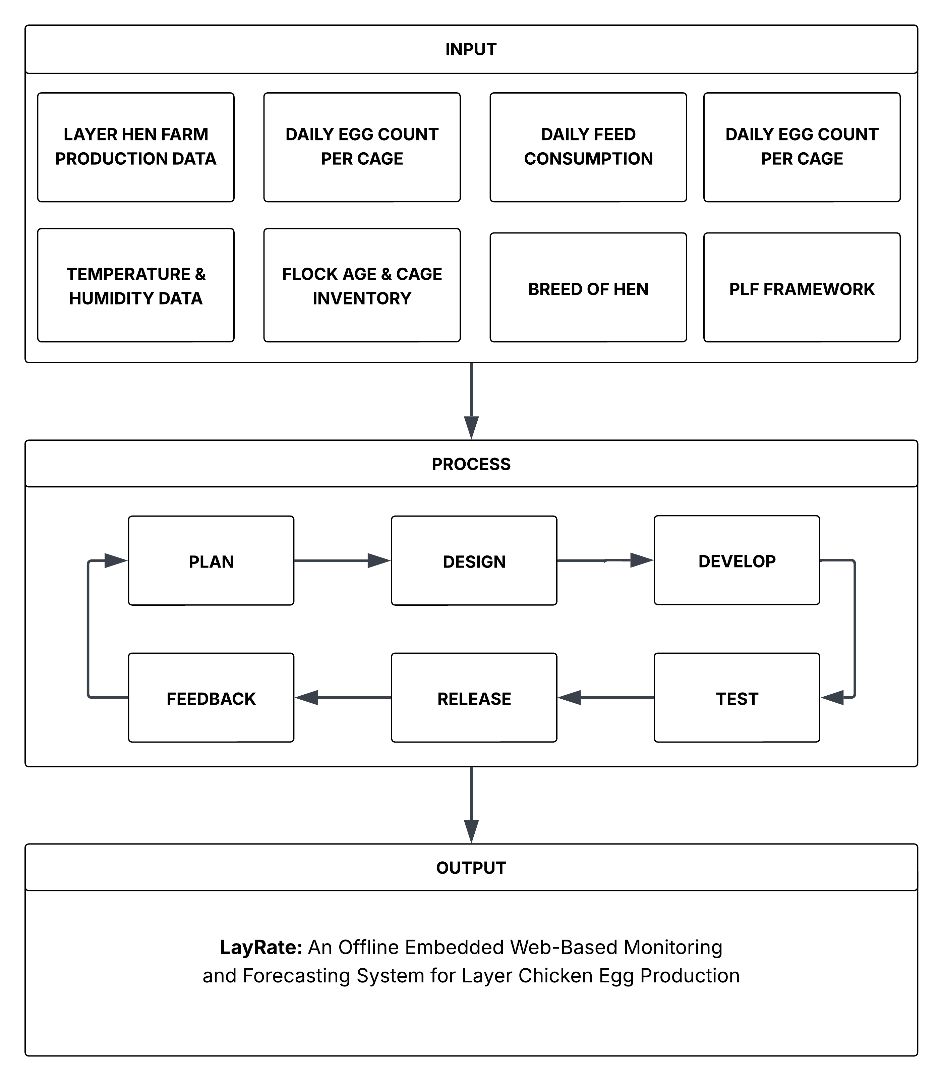
Fig. 2 Conceptual Framework of the Study.

SYNTHESIS
Studies show that internet and infrastructure problems in Philippine agriculture determine what kind of farm technology will actually work. Taer and Taer [1], Yasay [2], and Ugpat et al. [14] report that using IoT tools in local agribusiness is difficult because internet connectivity is unreliable, rural infrastructure is limited, and institutional support is weak. Cortez [3] adds that Filipino farmers only adopt technology if they find it useful and easy to use. Perin and Feliscuzo [15] reinforce that agricultural tools must match the technical skills and daily realities of local farmers. Salvia and Valderama [40] and Juan [41] further confirm this in the specific context of layer poultry farming, finding that farm performance in Philippine settings is shaped not only by production practices but also by environmental conditions such as heat stress, feed management systems, and climate factors that disproportionately affect farms without automated monitoring or decision-support tools. Together, these findings show that any monitoring system for Philippine farms must work without internet, be simple enough for non-technical users, and account for the operational and environmental realities that directly influence egg output in local farm conditions.
Although separate tools for smart poultry farming exist, they are rarely combined into one complete system. Local studies show that specific parts are possible: Maaño et al. [22] focus on monitoring incubation, while Ramizares et al. [23] demonstrate feed adjustment systems for broilers, and Sabado [24] and Simon and Palaoag [25] validate systems for production record management and environmental tracking. However, Villanueva et al. [16] and Monleon [17] note that small-scale farms still lack accessible, all-in-one monitoring tools, while Gerez et al. [18] further highlight that existing studies on sustainable poultry practices rely primarily on survey data rather than automated monitoring, underscoring the need for objective, data-driven production insights. Salvia and Valderama [40] and Juan [41] similarly found that Philippine layer farm operations depend on multiple interacting variables including housing conditions, disease control, temperature, and farm management practices whose combined effects on productivity cannot be adequately captured through manual observation or isolated monitoring tools alone. The variation in laying performance across commonly farmed breeds such as the Lohmann Brown-Classic, Dekalb White, and ISA Brown [19], [20], [21] further reinforces the importance of monitoring systems capable of not only tracking individual flock output against established breed-specific benchmarks, but also incorporating breed as a variable in production forecasting to account for inherent differences in laying performance across flocks. International studies by El Jarroudi et al. [13], Gong et al. [11], and Lin et al. [12] prove that local data processing through edge computing is feasible, and Wu et al. [37] demonstrate automated egg counting. Yet most of these solutions require stable internet or only track environmental conditions without combining production tracking and forecasting into a single offline platform. Jebari et al. [26], Hanau et al. [27], Ojo et al. [28], and Okubanjo et al. [29] further confirm that while IoT monitoring systems have advanced considerably, forecasting functionality remains consistently absent from existing implementations, leaving a critical decision-support gap unaddressed.
Computer models can now predict egg production accurately, offering practical solutions for farms. Bumanis et al. [6] establish that machine learning models specifically LSTM networks and XGBoost can forecast egg production well even when there is limited data, and critically found that XGBoost matched or outperformed LSTM under the data-scarce conditions characteristic of newly deployed small-scale farms. Ji et al. [38] further confirmed this by training seven machine learning models and finding XGBoost achieved the best predictive accuracy for egg production rate, with SHAP analysis identifying feed intake as the second most important input feature. Morales-Suárez et al. [39] and Li et al. [36] similarly demonstrate that predictions become substantially more accurate when the right input variables — particularly feed intake and flock age — are incorporated. Wu et al. [37] additionally show that automated egg counting is technically achievable, though current implementations demand high-performance hardware unsuitable for small-scale farm deployment. These findings collectively confirm that proven forecasting methods, specifically XGBoost as the primary model and SARIMA as a time-series baseline, can run on local farm hardware without requiring cloud servers, and that predictive performance should be quantitatively verified through MAE, RMSE, and MAPE.
What hens eat is a key factor in predicting egg production and must be included in any forecasting model. Heo et al. [30], Da Nóbrega et al. [31], [32], Lee et al. [33], Wilkinson et al. [34], and Wu et al. [35] consistently show that daily feed intake and crude protein levels are the primary determinants of egg mass, laying rate, and feed efficiency. Li et al. [36] further establish that laying rate and daily feed intake are the two most consequential variables governing feed conversion ratio and production efficiency. These studies justify using feed consumption and crude protein content as primary forecasting inputs rather than treating them as secondary details, providing a biologically grounded basis for LayRate's forecasting module design. Alongside these nutritional variables, breed also plays a significant role in determining laying performance, as the documented differences in production persistency and egg output among commercially farmed breeds [19], [20], [21] establish breed as a necessary input variable to ensure that forecasts accurately reflect flock-specific production patterns. Salvia and Valderama [40] and Juan [41] extend this further by establishing that in Philippine layer farming specifically, environmental temperature and farm management practices are not peripheral concerns but integral production variables heat stress in tropical conditions measurably reduces feed intake and laying performance, meaning that temperature data collected alongside production and feed records provides additional forecasting signal that is especially relevant to local farm conditions.
Across these areas, a clear gap exists: although monitoring tools, feeding systems, predictive models, and nutritional guides have been studied individually, there is no integrated offline system designed specifically for small- to medium-scale layer farms in the Philippines. The combination of internet constraints, separate technologies, proven forecasting methods, nutritional science, and locally documented operational realities including the impact of heat stress and farm management quality on Philippine layer productivity confirmed by Salvia and Valderama [40] and Juan [41] highlights the need for a unified solution. This gap directly supports the development of LayRate as an integrated, offline web-based monitoring and forecasting platform. LayRate will be designed to work without internet, prioritize ease of use for farm operators, and use feed consumption, crude protein, mortality, breed, flock age, and environmental temperature as essential inputs for accurate, biologically grounded production forecasting using XGBoost validated against a SARIMA baseline, with predictive performance measured through MAE, RMSE, and MAPE.
CHAPTER III
DESIGN AND METHODOLOGY
This chapter discusses the methodology of the study, including the research design, development process, and implementation approach. It outlines the tools, techniques, and procedures used to ensure the system's effectiveness and reliability. Additionally, it describes the testing and evaluation methods employed to validate the proposed solution.
RESEARCH DESIGN
This study will employ the descriptive-developmental research design, which focuses on understanding an existing problem and developing a technological solution to address it. This design is suitable for studies that involve the design and implementation of innovative systems, as it allows researchers to systematically build and assess the effectiveness of new technologies in solving identified problems. This approach will serve as a guide in developing LayRate: An Offline Web-Based Layer Farm Monitoring and Egg Production Forecasting System for layer farm operators in the Philippines.
The descriptive-developmental research design consists of several iterative phases which include the following: Planning, System Development, Testing, Deployment, and Evaluation. The process begins with the descriptive phase, which involves identifying the current challenges in egg production monitoring among small- to medium-scale layer farms, including the absence of automated, data-driven monitoring and forecasting tools that can operate without internet connectivity.
Following the descriptive phase, the development of the system will be carried out based on the findings gathered. This includes the design and implementation of LayRate, which integrates DHT22-based temperature and humidity sensors, IR break beam sensors for automated egg counting, an Arduino-to-Raspberry Pi data pipeline, and machine learning forecasting models using XGBoost regression and SARIMA, along with supporting features such as a real-time monitoring dashboard, alert and threshold notifications, historical data reporting, and role-based access control. Continuous testing and refinement will be conducted throughout the development process to ensure that the system functions as intended and is capable of meeting the needs of its target users.
To objectively evaluate the performance of the developed system, this study will adopt a quantitative approach using benchmarking tools. Specifically, Apache JMeter and other performance testing utilities will be used to measure the system’s response time, throughput, scalability, and reliability under load. Python evaluation scripts will be used to compute the forecasting accuracy of the XGBoost and SARIMA models using MAE, RMSE, and MAPE against a withheld ground truth dataset. This method will enable the collection of precise and measurable data that can be objectively interpreted to determine the system’s overall technical performance and its readiness for actual farm deployment.
RESEARCH METHODS
Locale of the Study
This study will be conducted at a small- to medium-scale layer hen farm located in Nasugbu, Batangas, Philippines. The farm was selected as the study site based on its representativeness of the target deployment context — a semi-commercial layer operation that currently relies on manual egg collection and has no existing digital monitoring or production forecasting tools in place. The farm’s offline operational environment, limited internet connectivity, and cage-based layer housing configuration make it an appropriate and contextually valid setting for the development and initial deployment of LayRate. The farm owner has expressed willingness to participate in the requirements-gathering phase of the study and to allow the deployment of the system within the farm premises during the evaluation period.

Respondents of the Study
Given that this study employs a purely technical evaluation approach without the administration of a survey instrument to human respondents, the primary participant in this study is the layer farm operator of the participating farm in Nasugbu, Batangas. The farm operator’s involvement is limited to the Planning Phase, wherein informal semi-structured interviews will be conducted to identify operational pain points, current monitoring practices, and specific system requirements that will directly inform the design and development of LayRate. The system itself — LayRate — will serve as the primary subject of technical evaluation, assessed through benchmarking tools, automated testing frameworks, and forecasting accuracy metrics as described in the Instrumentation section of this chapter.
Data Sources
The primary data source for system evaluation will be the ground truth dataset consisting of actual daily production records collected from the participating layer farm during the deployment phase. This dataset will include daily egg counts per cage, temperature and humidity sensor readings, feed consumption records, dietary crude protein entries, mortality logs, flock age, and breed information. A portion of this dataset will be withheld from model training and used exclusively for evaluating the predictive accuracy of the XGBoost and SARIMA forecasting models. Sensor accuracy will be validated by comparing DHT22 readings against reference instrument measurements collected during a dedicated calibration period. No human respondents will complete evaluation questionnaires; all performance and accuracy data will be collected through automated benchmarking tools and computational evaluation scripts.
Data Collection Instruments
This study will employ the following instruments for data collection and system evaluation. First, an interview guide will be used during the Planning Phase to facilitate informal semi-structured interviews with the participating farm operator. The interview guide will be designed to elicit information on current egg production monitoring practices, operational pain points, data recording habits, and specific management needs that the LayRate system should address. The responses gathered through these interviews will directly inform the system’s functional requirements and design decisions.
Second, Apache JMeter test plans will be configured to measure system performance in terms of response time, throughput, scalability, and reliability under simulated concurrent load. Third, Selenium and Playwright automation scripts will be used to verify the functional correctness of the web-based dashboard across all major system features and user workflows. Fourth, Postman API test collections will validate the correctness and reliability of all backend API endpoints. Fifth, Python evaluation scripts will compute MAE, RMSE, and MAPE by comparing XGBoost and SARIMA model outputs against the withheld ground truth dataset. Sixth, the Arduino Serial Monitor alongside readings from calibrated reference instruments will be used to validate the accuracy of DHT22 temperature and humidity sensor outputs during the calibration phase.
Statistical Treatment of Data
Since this study does not employ a survey instrument, no weighted mean computation will be applied. Quantitative evaluation data will be analyzed using the following approaches. Forecasting accuracy will be assessed using Mean Absolute Error (MAE), Root Mean Square Error (RMSE), and Mean Absolute Percentage Error (MAPE), computed between the predicted and actual HDEP values in the withheld test dataset for both the XGBoost and SARIMA models. Sensor calibration accuracy will be evaluated by computing the Mean Absolute Error between DHT22 sensor readings and corresponding reference instrument values across a series of calibration readings per sensor unit.
System performance benchmarking data collected through Apache JMeter and related tools will be tabulated and analyzed descriptively, with results reported in terms of average response time (ms), throughput (requests per second), degradation rate (%) under increasing concurrency levels, and error rate (%) under sustained load conditions. Functional test outcomes from Selenium, Playwright, and Postman will be recorded as Pass/Fail results per test case and summarized as an overall functional compliance rate across all system features. Together, these approaches will provide a comprehensive quantitative basis for evaluating the technical performance, forecasting reliability, and functional correctness of the LayRate system.

DESIGN STAGE OF THE PROCESS
The Software Development Life Cycle (SDLC) is a structured framework used to guide the systematic development of software systems, ensuring efficiency, reliability, and high quality in the final product. It provides an organized approach to minimizing potential risks while optimizing the use of available resources throughout the development process. In this study, the LayRate system was designed and implemented using the Agile development approach.
Agile methodology promotes continuous feedback, iterative enhancement, and effective resolution of system issues. The development process of the system was organized into six major phases.
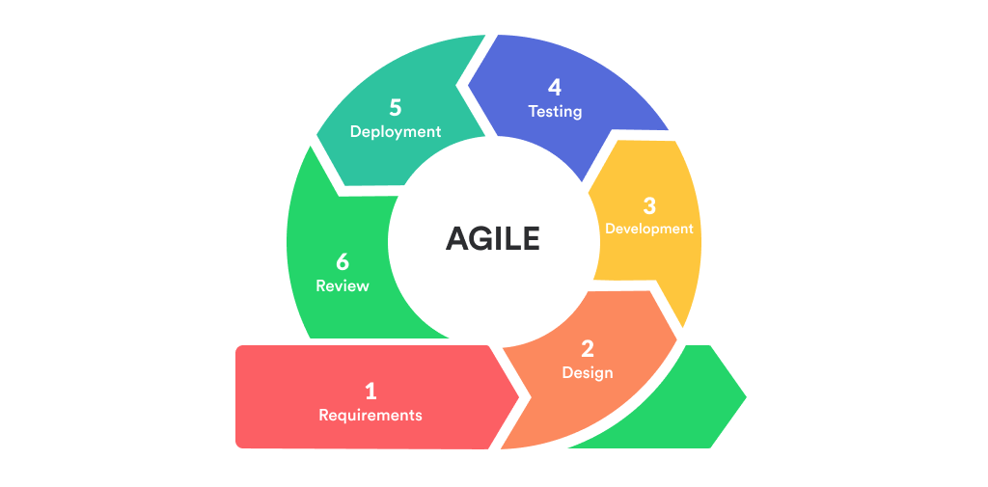
Fig. 3 Agile Methodology [52]
Figure 3 illustrates the phases and processes of the Agile development methodology utilized in the completion of the project. The Agile Software Development Life Cycle (SDLC) is an iterative and adaptable framework that accommodates evolving requirements while maintaining a structured, timely, and efficient development process. It consists of the following phases: Planning/Requirements, Designing, Developing, Testing, Deployment, and Reviewing.
The researchers selected the Agile methodology for the development of LayRate: An Offline Web-Based Layer Farm Monitoring and Egg Production Forecasting System. Through the implementation of Agile, the research team was able to incrementally develop and enhance the system while gradually integrating its essential features. These include the Arduino sensor data pipeline, real-time monitoring dashboard, automated egg counting, machine learning forecasting using XGBoost regression and SARIMA, alert and threshold notification, and historical production reporting. This approach ensured that the operational needs of layer farm owners remained central throughout the development process. Compared to traditional linear development models, Agile supports continuous validation and iterative improvements, which help reduce risks and enhance the overall quality and functionality of the system.

Planning Phase
In the Planning Phase, the research team will focus on understanding the actual workflow and operational challenges of small- to medium-scale Layer Hen farms. The researchers will conduct informal interviews with a farm owner in Nasugbu, Batangas, to identify specific pain points such as the absence of automated egg counting, inconsistent environmental monitoring, and the complete lack of production forecasting tools. From these consultations, the team will identify the core system requirements: automated Hen-Day Egg Production (HDEP) computation, real-time temperature and humidity monitoring using DHT22 sensors, daily feed consumption and crude protein recording, and a production forecasting module using XGBoost as the primary model and SARIMA as a baseline comparison.
To ensure that the selected baseline model is both technically appropriate and feasible within the system’s constraints, the researchers further justify the inclusion of SARIMA as follows. SARIMA — Seasonal Autoregressive Integrated Moving Average — was selected as the time-series baseline model for the LayRate forecasting module on the basis of several complementary considerations. As a univariate time-series model, SARIMA is well-suited to modeling Hen-Day Egg Production (HDEP) data, which exhibits the type of seasonal and cyclical patterns — such as weekly laying rhythms and gradual production decline across the flock's laying cycle — that SARIMA's seasonal differencing and autoregressive components are specifically designed to capture. SARIMA models have been widely adopted as baseline comparators in agricultural and biological time-series forecasting literature, establishing a recognized standard against which the primary XGBoost model's performance can be meaningfully benchmarked. Computationally, SARIMA is lightweight and fully executable within the resource-constrained environment of a Raspberry Pi 4 Model B, requiring no GPU acceleration or large memory overhead. In evaluating alternative time-series approaches, ARIMA was excluded because it lacks seasonal components, making it structurally less appropriate for HDEP data that exhibits periodic laying patterns; Prophet was not selected because it is optimized for daily trend decomposition with holiday effects and requires more data volume than is expected during the initial deployment period of a newly commissioned small-scale farm system; and Holt-Winters exponential smoothing, while computationally simple, provides less interpretability and fewer diagnostic tools than SARIMA for assessing model fit in a research evaluation context. LSTM-based deep learning models were similarly excluded in this iteration, as documented in the Scope and Limitation of the Study, due to their substantially higher sequential data requirements relative to what is available during the system's initial operational period.
Building on these modeling decisions, the team will also establish the technical constraints of the deployment environment, particularly the absence of reliable internet connectivity, which will direct the decision to design LayRate as a fully offline, locally hosted system running on a Raspberry Pi 4 Model B. These detailed requirements will serve as the foundation for the entire project direction.

Designing Phase
During the Designing Phase, the team will develop a comprehensive blueprint for LayRate's architecture, interface, and data flow. The system architecture will be structured around an embedded IoT design pattern in which the Arduino Uno R3 will collect egg count, temperature, and humidity data from sensors and forward these readings to the Raspberry Pi 4 Model B, which will serve as the local server and edge computing device. The researchers will select Laravel as the web application framework following the Model-View-Controller (MVC) pattern, MySQL as the relational database managed through Laravel's Eloquent ORM, and Python for implementing the forecasting module. Hardware schematics will be drafted to define the placement and wiring of the IR Break Beam sensor for egg counting and the DHT22 sensor for environmental monitoring inside the layer cage. Database schemas will be designed to associate each daily egg count, feed consumption, crude protein, and environmental record with a specific cage, date, flock age, mortality, and breed, ensuring that the forecasting module will be able to retrieve properly structured time-series inputs. Use case diagrams, data flow diagrams, and entity-relationship diagrams will also be developed to map interactions between the farm operator, the embedded hardware, and the web-based dashboard. Basic user interface wireframes will be drafted to prioritize simplicity and ease of navigation, consistent with the finding that Filipino farmers adopt technology primarily based on perceived usefulness and ease of use.

Development Phase
In the Development Phase, the team will implement the full LayRate system across its hardware and software components. On the hardware side, the Arduino Uno R3 will be programmed using C++ with Arduino libraries to interface with the DHT22 and IR Break Beam sensors, collect real-time readings, and transmit structured data to the Raspberry Pi 4 Model B via serial communication. On the software side, the Laravel web application will be built to support cage management, hen inventory tracking, daily egg production recording, automatic HDEP computation, environmental monitoring, feed and crude protein logging, and user administration with access control.
The MySQL database will be configured and integrated with the application to store all historical production, environmental, and nutritional records in a structured, queryable format. The forecasting module will be developed in Python, implementing XGBoost in regression mode as the primary predictive model taking daily feed consumption, dietary crude protein level, temperature, humidity, flock age, mortality, and breed as input features, alongside SARIMA as a time-series baseline model using historical HDEP data. Forecasting accuracy will be evaluated using Mean Absolute Error (MAE) and Root Mean Square Error (RMSE). Throughout development, the team will continuously test individual components, address issues such as sensor reading inconsistencies, database query performance, and interface responsiveness, and refine the system iteratively before proceeding to full-scale testing.

Testing Phase
In the Testing Phase, LayRate will be evaluated by actual farm operators and selected experts to verify that all features will perform correctly under real operational conditions. Sensor calibration will be conducted to confirm the accuracy of egg count detection through the IR Break Beam sensor and the temperature and humidity readings from the DHT22 sensor. The HDEP computation will be validated against manually verified egg counts to ensure correctness. The forecasting module will be tested by running both XGBoost and SARIMA models on accumulated production data and comparing their outputs against actual recorded HDEP values using MAE and RMSE metrics. Farm operators and IT experts will assess the system’s functional suitability, reliability, performance efficiency, usability, and security. Issues identified during this phase, including interface inconsistencies, alert threshold inaccuracies, and data visualization gaps, will be documented and addressed before final deployment.

Deployment Phase
In the Deployment Phase, the finalized LayRate system will be installed and configured within the layer farm environment. The Raspberry Pi 4 Model B will be set up as the local server, with the Laravel web application, MySQL database, and Python forecasting module fully deployed and operational without requiring internet connectivity. The Arduino Uno R3 and its connected sensors will be physically integrated within the layer cage housing, with the IR Break Beam sensor positioned at the designated egg collection point and the DHT22 sensor placed inside the poultry coop to capture representative environmental readings. Farm operator accounts will be created, and the web-based dashboard will be made accessible through their browser connected to the farm's local network.
During the deployment period, the team will monitor system stability, verify that sensor data is being transmitted and stored correctly, confirm that HDEP computations and forecasting outputs are generating as expected, and ensure that automated alerts for abnormal production or environmental conditions are functioning properly. This phase will validate that LayRate operates reliably as a fully offline, integrated monitoring and forecasting platform suited to the conditions of small- to medium-scale Philippine layer farms.

DEVELOPMENT PROCESS
This segment will discuss the development process of the LayRate system, which will involve testing, debugging, and validation. First, the system's modules including egg production recording, environmental monitoring, feed intake tracking, and forecasting will be developed and tested for functionality. Hardware components such as the Arduino Uno R3 and sensors will be configured, while the Raspberry Pi 4 Model B will serve as the local edge server. During development, the embedded firmware, offline database, and web-based dashboard will be integrated to ensure smooth data collection, storage, and visualization. These steps will be repeated iteratively to enhance the system's reliability, usability, and performance in offline poultry farm environments.

Testing Process
The testing process will ensure that the LayRate system works correctly before deployment. Unit testing will check individual functions, such as egg count logging, temperature and humidity measurement, and feed consumption recording. Integration testing will verify that these features work together — for example, that sensor readings are accurately stored in the offline database and reflected on the web-based dashboard. User acceptance testing will involve Layer Hen farm operators performing daily tasks, ensuring that the system is easy to use, reliable, and aligned with the practical needs of managing egg production efficiently.

Debugging Process
The debugging process will involve identifying, analyzing, and correcting errors discovered during testing of the LayRate system. Developers will use debugging tools, system logs, and real-time monitoring to trace issues in modules like sensor readings, database communication, and forecasting calculations. Methods such as code review, scenario testing, and calibration adjustments will be applied to fix problems including incorrect egg counts, environmental data anomalies, and offline data syncing failures. This process will ensure the system operates smoothly, maintains accurate data, and provides a dependable tool for farm decision-making.

Validation Process
System validation will confirm that the LayRate system meets the actual requirements of Layer Hen farm operators. The process will involve verifying the accuracy of egg production and environmental data, testing forecasting outputs against historical trends, and assessing the usability of the web-based dashboard. Farmers will provide feedback on improving features, such as optimizing feed tracking and adjusting alert notifications for anomalies. This validation will ensure that LayRate delivers a practical, data-driven solution that improves productivity, supports timely decisions, and enhances overall farm management.

PROGRAMMING PROCEDURE
The system architecture, requirements analysis, use case diagram, context diagram, data flow diagram, and entity relationship diagram will all be components of the developed system's programming procedure. The diagrams will serve as a guide throughout the methods that will be used in the development of the system.
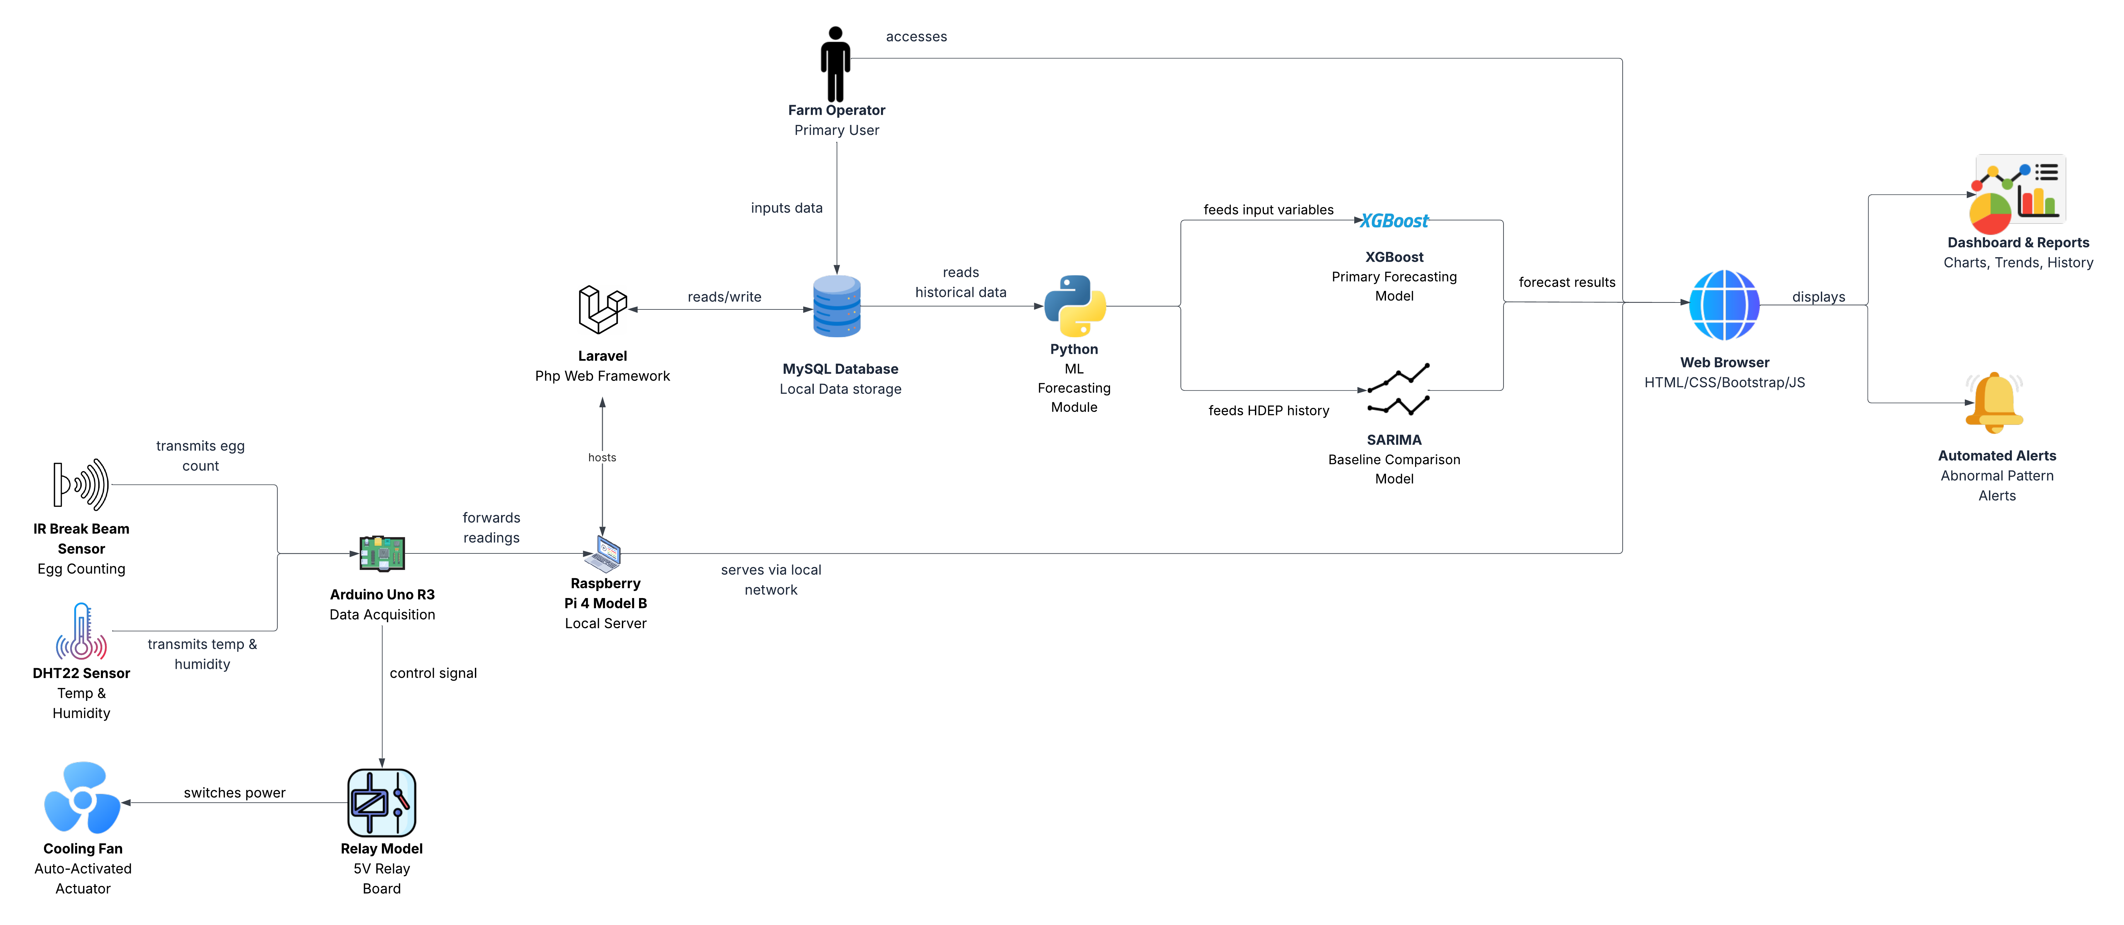
System Architecture
Fig. 4 System Architecture of LayRate
Fig. 4 shows how data will flow across the different components of the LayRate system. At the sensing layer, the IR Break Beam Sensor will transmit egg count data to the Arduino Uno R3, while the DHT22 Sensor will transmit temperature and humidity readings to the same microcontroller. The Arduino Uno R3 will then forward all collected readings to the Raspberry Pi 4 Model B, which will serve as the local server. Additionally, the Arduino Uno R3 will serve as the control unit for the output actuator path when the measured temperature exceeds the configured threshold, it will send a temperature threshold signal to the Relay Module, which will in turn switch the Cooling Fan ON or OFF to provide automated heat stress mitigation inside the coop. Within the Raspberry Pi, the Laravel framework will read and write data to the MySQL database, and the Python machine learning module will read historical data from that same database to generate production forecasts. The Raspberry Pi will serve the web application to the browser through the farm's local network without requiring internet access. The Farm Operator will access the system through the browser to input feed and production data into Laravel, and will view results through the Dashboard and Reports and Automated Alerts, both of which will be displayed via the browser.
Forcasting Models
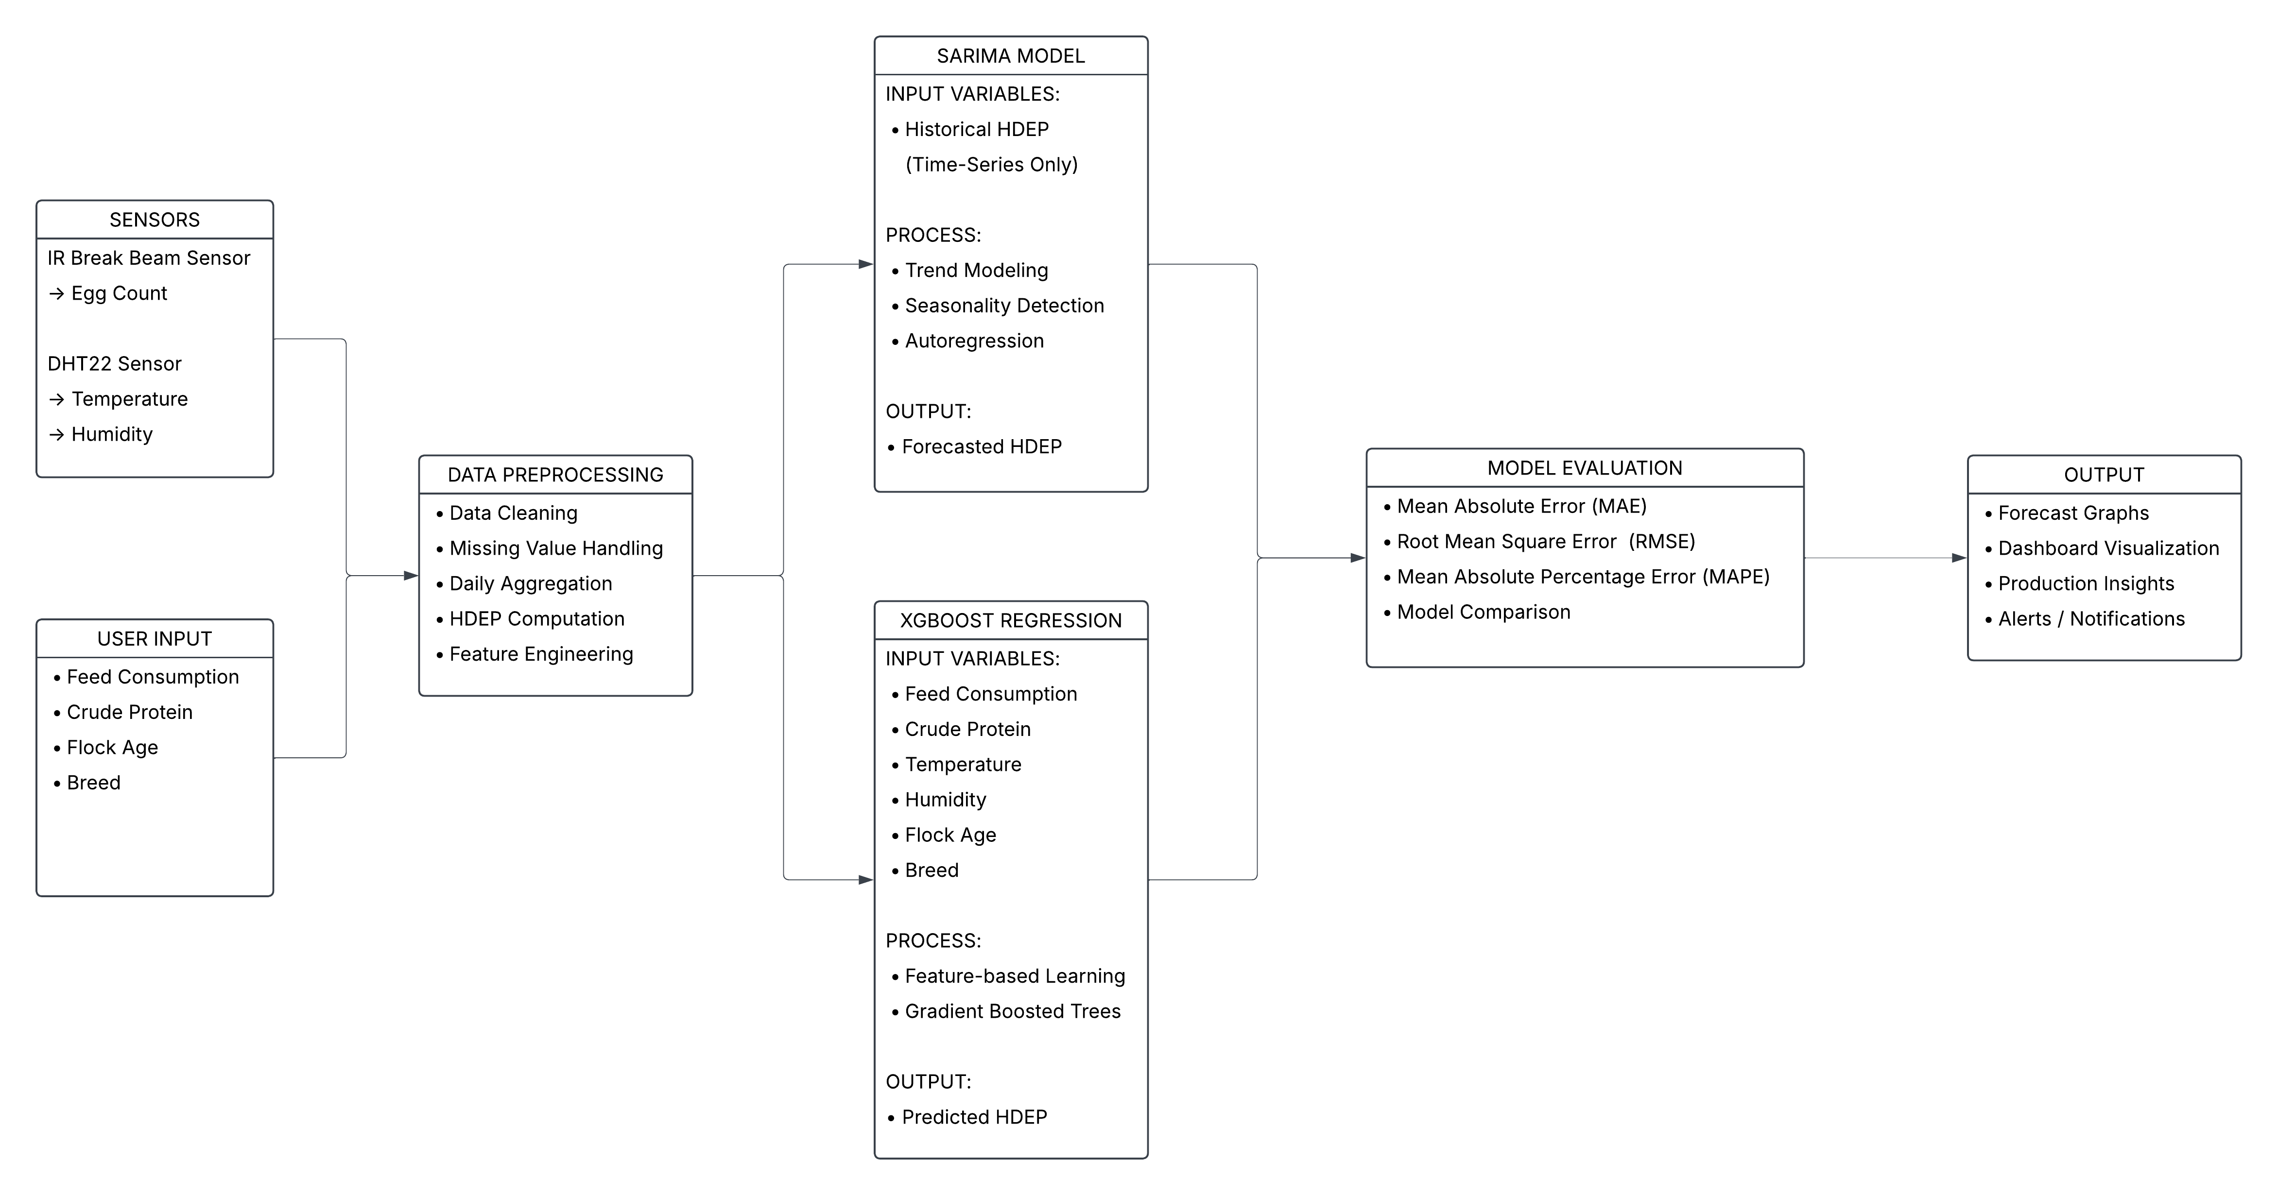
Fig. 5 Forecasting Model of LayRate
The diagram illustrates the complete forecasting pipeline of the system. Sensor-acquired data from the IR Break Beam sensor (egg count) and DHT22 sensor (temperature and humidity), along with user-input variables such as feedn consumption, crude protein, flock age, and breed, are processed and transformed into structured features including Hen-Day Egg Production (HDEP). The system applies two forecasting approaches: XGBoost regression, which utilizes multivariate inputs, and SARIMA, which models historical HDEP as a univariate time series. Model performance is evaluated using MAE, RMSE, and MAPE, and the resulting forecasts are presented through the system dashboard to support data-driven farm management decisions

Physical Network Setup Diagram
Figure 6. Physical Network Setup Diagram of LayRate
Figure 6 illustrates the physical network setup of the LayRate system, depicting the hardware interconnections between the embedded computing devices, the sensors integrated within the layer cage environment, and the client devices used by farm operators to access the monitoring platform.
At the core of the physical setup is the Raspberry Pi 4 Model B, which serves as the central local server and edge computing hub of the entire LayRate system. Rather than relying on an external internet connection or cloud infrastructure, the Raspberry Pi hosts the Laravel web application, manages the MySQL database, and executes the Python-based forecasting module entirely within the farm's local environment. To enable wireless access across the farm premises without requiring a pre-existing network infrastructure, the Raspberry Pi is configured to broadcast its own wireless hotspot, effectively functioning as a self-contained local area network (LAN) access point. This design decision directly addresses the infrastructure constraints commonly encountered in rural Philippine farm settings, where stable internet connectivity is often unavailable or unreliable.
Connected to the Raspberry Pi via a USB serial cable is the Arduino Uno R3, which functions as the dedicated data acquisition unit of the embedded system. The USB connection serves a dual purpose: it supplies power to the Arduino board and simultaneously provides the serial communication channel through which sensor readings are continuously transmitted from the Arduino to the Raspberry Pi. This separation of responsibilities wherein the Arduino handles low-level hardware interfacing and the Raspberry Pi handles application-level processing and storage — reflects a well-established IoT design pattern that improves system modularity, reliability, and maintainability by isolating sensor interaction from higher-order computational tasks.
Two categories of sensors are physically integrated into the layer cage structure and wired directly into the Arduino Uno R3. The first is the DHT22 Temperature and Humidity Sensor, which is mounted within the poultry housing area to continuously capture the environmental conditions inside the coop. Temperature and humidity readings collected by this sensor are forwarded through the Arduino to the Raspberry Pi, where they are stored in the local database and made visible through the monitoring dashboard. These environmental records also serve as input variables for the XGBoost production forecasting module, reflecting the established relationship between thermal and humidity conditions and laying hen productivity.
The second sensor type is the IR Break Beam Sensor, which is composed of a transmitter and a receiver unit positioned on opposite sides of the egg collection path at the base of the layer cage. As eggs roll from the cage and pass through the detection zone, the infrared beam between the transmitter and receiver is interrupted, registering each egg as a discrete count. This contactless detection mechanism enables fully automated, real-time egg counting without requiring manual tallying by farm personnel. The IR sensor's output signals are read and processed by the Arduino Uno R3, which aggregates the egg count data and transmits it to the Raspberry Pi for storage, HDEP computation, and display on the web-based dashboard.
On the client access side, the diagram shows a laptop computer and a mobile phone connected wirelessly to the hotspot broadcast by the Raspberry Pi. Both devices access the LayRate web application through any standard web browser, without the need to install additional software. This browser-based access model ensures compatibility with a wide range of devices already available on the farm, lowering the barrier to adoption among non-technical farm operators. The dashboard, production reports, alert notifications, and forecasting outputs generated by the system are all accessed through this wireless interface, enabling farm operators to monitor and manage egg production from anywhere within the hotspot's coverage area.
Taken together, the physical network setup of LayRate forms a fully self-contained, offline-capable IoT architecture. Data originates at the sensor layer, passes through the Arduino microcontroller, is forwarded to the Raspberry Pi for processing and storage, and is ultimately presented to the farm operator through a browser-connected device over the local wireless network — all without any dependence on external internet connectivity. This closed-loop hardware configuration ensures that LayRate remains fully operational under the connectivity constraints characteristic of small to medium-scale poultry farms in rural areas of the Philippines, making it a practical and contextually appropriate solution for modern, data-driven layer farm management.

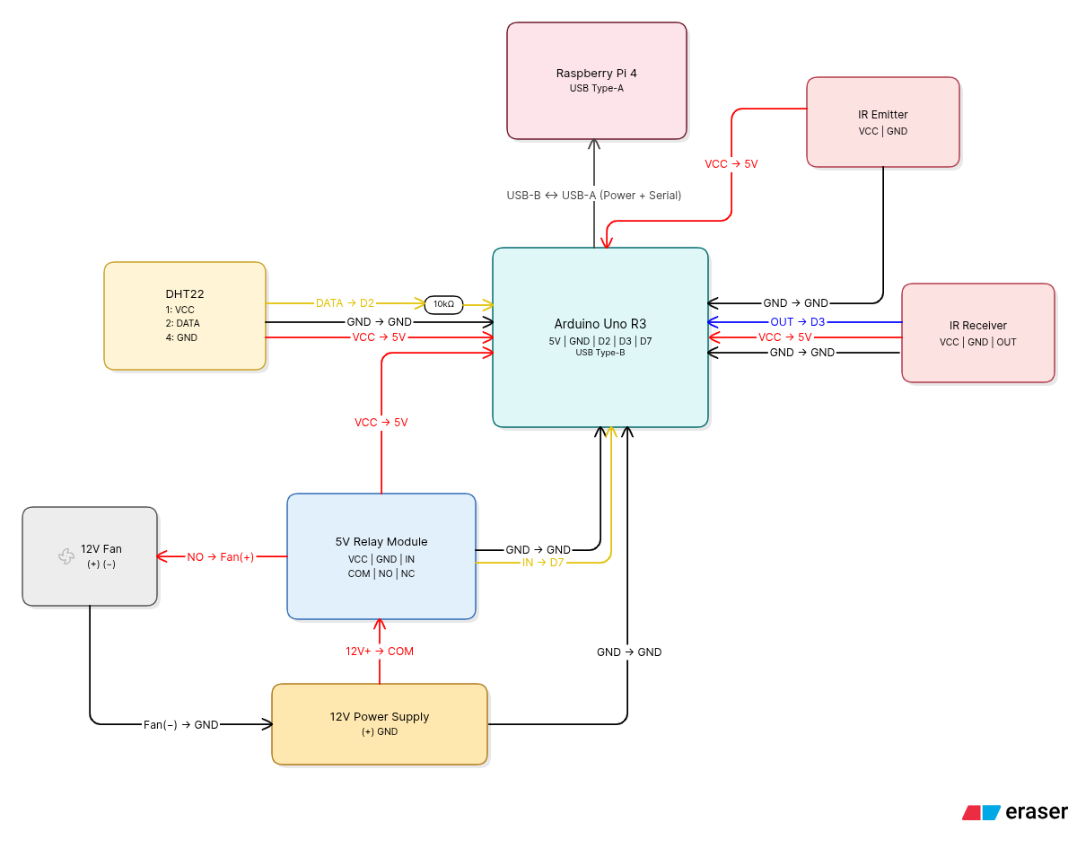
Schematic Diagram
Fig. 7 Schematic Diagram of LayRate
Figure 7 presents the embedded hardware system schematic of LayRate, illustrating the detailed electrical connections and signal pathways between each hardware component that constitutes the system's sensor and control layer. Unlike the physical network setup diagram, this schematic focuses on the low-level wiring configuration specifying pin assignments, wire functions, voltage levels, and inter-component relationships at the circuit level.
At the center of the schematic is the Arduino Uno R3, which serves as the primary microcontroller responsible for interfacing with all connected sensors and actuators. The Arduino exposes several key pins used throughout the schematic: the 5V power rail, GND, and digital pins D2, D3, and D7, along with a USB Type-B port for serial communication.
Connected to the upper portion of the schematic is the Raspberry Pi 4, linked to the Arduino via a USB Type-B to USB Type-A cable. This connection simultaneously delivers power to the Arduino and establishes the serial communication channel through which sensor data is continuously transmitted to the Raspberry Pi for processing and storage.
On the right side of the schematic, the IR Break Beam Sensor assembly is depicted, consisting of an IR Emitter and an IR Receiver module. The IR Emitter receives 5V power (VCC → 5V) and a shared GND from the Arduino's power rail. The IR Receiver is similarly powered through VCC → 5V and GND connections, while its signal output line (OUT → D3) feeds directly into digital pin D3 of the Arduino, registering each egg passage as a discrete interrupt signal. A 10kΩ pull-up resistor is indicated on the signal line to ensure stable logic-level readings.
On the left side, the DHT22 Temperature and Humidity Sensor is wired to the Arduino with its DATA line connected to digital pin D2 (DATA → D2), a VCC line supplying 5V power (VCC → 5V), and two GND connections completing the circuit. This sensor continuously measures ambient temperature and humidity within the poultry housing environment, forwarding readings through the Arduino to the Raspberry Pi.
At the lower section of the schematic, a 5V Relay Module is integrated into the circuit to enable automated control of external hardware. The relay receives its control signal from digital pin D7 of the Arduino (IN → D7) and shares a common GND connection. The relay's COM terminal is connected to the positive line of the 12V Power Supply (12V+ → COM), while its Normally Open (NO) terminal is wired to the positive terminal of the 12V Fan (NO → Fan(+)). The fan's negative terminal is grounded through the 12V power supply's GND line (Fan(−) → GND), completing the fan control circuit. This configuration allows the Arduino to programmatically activate or deactivate the ventilation fan based on temperature thresholds detected by the DHT22 sensor.
A Wire Color Legend is provided in the upper-left corner of the schematic to standardize the interpretation of all connections: red wires denote VCC or power lines (+); black wires represent GND or ground connections; yellow wires carry Data or Control signals; blue wires carry Sensor Output signals; and white wires indicate Shared GND lines. Filled black circles along the 5V rail mark shared VCC junction points where multiple components draw power from a common node.
Taken together, the schematic illustrates a modular and clearly organized embedded circuit in which the Arduino Uno R3 acts as the central hub, coordinating real-time data acquisition from the DHT22 and IR sensors while simultaneously managing automated fan control through the relay module — all while maintaining a continuous data uplink to the Raspberry Pi over USB serial communication.

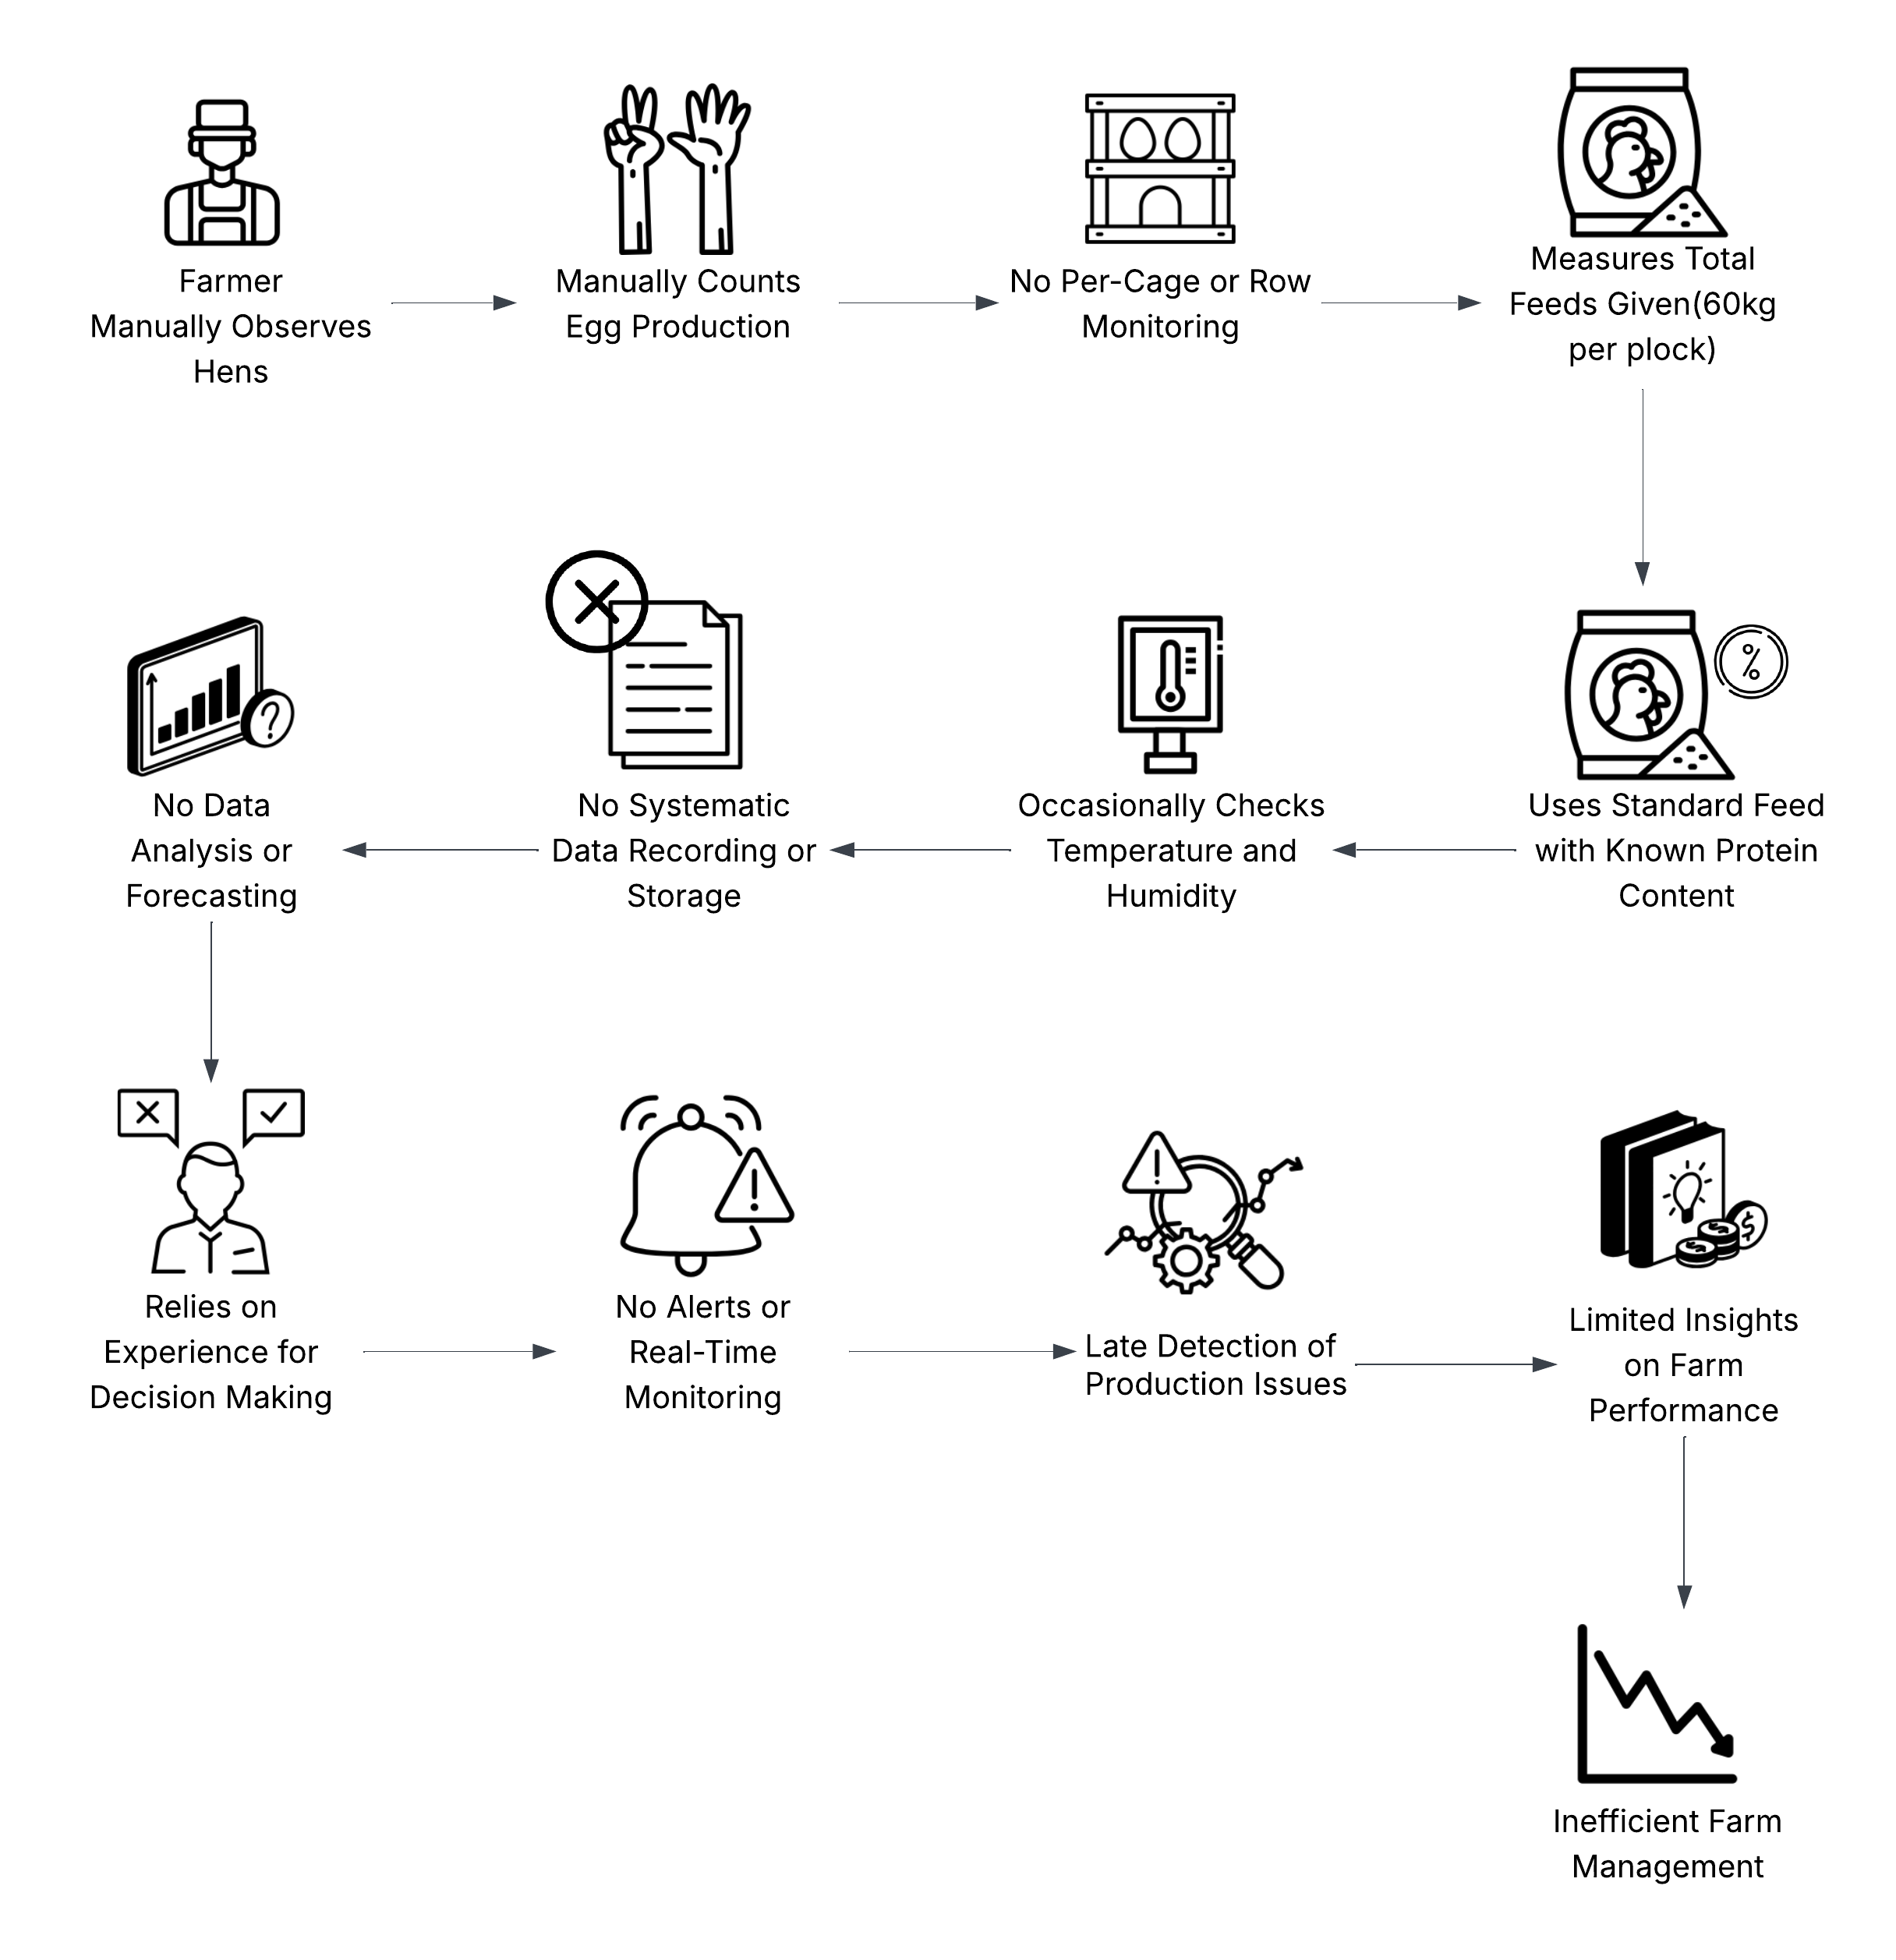
Requirements Analysis
Fig. 8 Requirements Analysis of LayRate
Fig. 8 illustrates how Layer Hen farm operations are currently managed without the use of a digital system. In this traditional setup, farmers manually observe the hens and count the total egg production for the flock, without monitoring production at the per-cage or per-row level. Feed is measured in total amounts (e.g., 60 kg per flock) and administered according to standard protein content guidelines. Environmental conditions such as temperature and are checked occasionally, but there is no systematic recording of these observations.
All operational data is either not recorded or maintained in an unstructured manner, preventing meaningful data analysis or forecasting. As a result, decision-making relies primarily on the farmer’s personal experience rather than actionable insights from historical data.
The lack of real-time monitoring and automated alerts leads to late detection of production issues and limits visibility into the farm’s overall performance. Farmers cannot easily identify trends, predict problems, or optimize feed and egg production. This reliance on manual methods results in inefficiencies, reduced productivity, and potential economic losses.
These limitations highlight the need for a digital farm monitoring and forecasting system like LayRate. By automating data collection, tracking environmental conditions, monitoring feed usage, and providing timely alerts, the system would enable more informed decision-making, efficient resource management, and improved overall farm performance.

Use Case Diagram
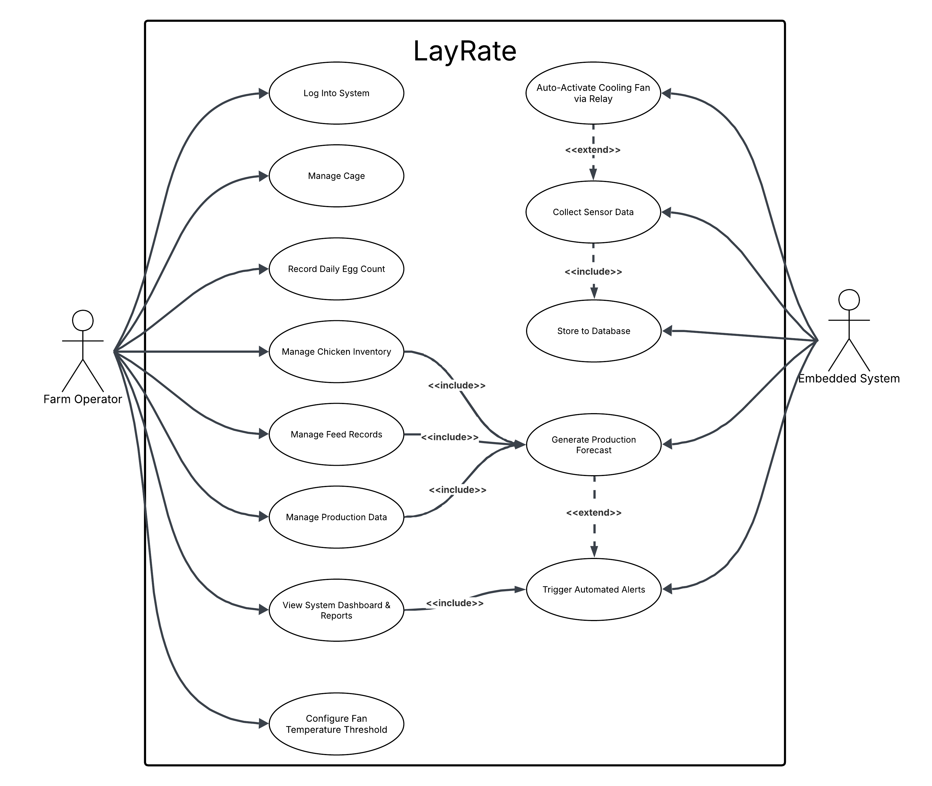
Fig. 9 Use Case Diagram of LayRate
The Fig. 9 presents the interactions between the actors and the functional features of the LayRate system. The Farm Operator will be the sole human actor, responsible for all manual interactions with the system such as logging in, managing cage and hen records, recording daily egg counts, inputting mortality, feed consumption and crude protein levels, and viewing the dashboard, reports, and alerts. The Embedded System, composed of the Arduino Uno R3 and its connected sensors, will act as a secondary actor that will operate independently to collect sensor data. Recording the daily egg count will automatically include the computation of the Hen-Day Egg Production (HDEP), while inputting both feed consumption and crude protein level will each include the generation of a production forecast. The sensor data collection process will include storing readings to the local database, which will conditionally extend into triggering automated alerts whenever abnormal production, environmental, or feed intake patterns are detected.

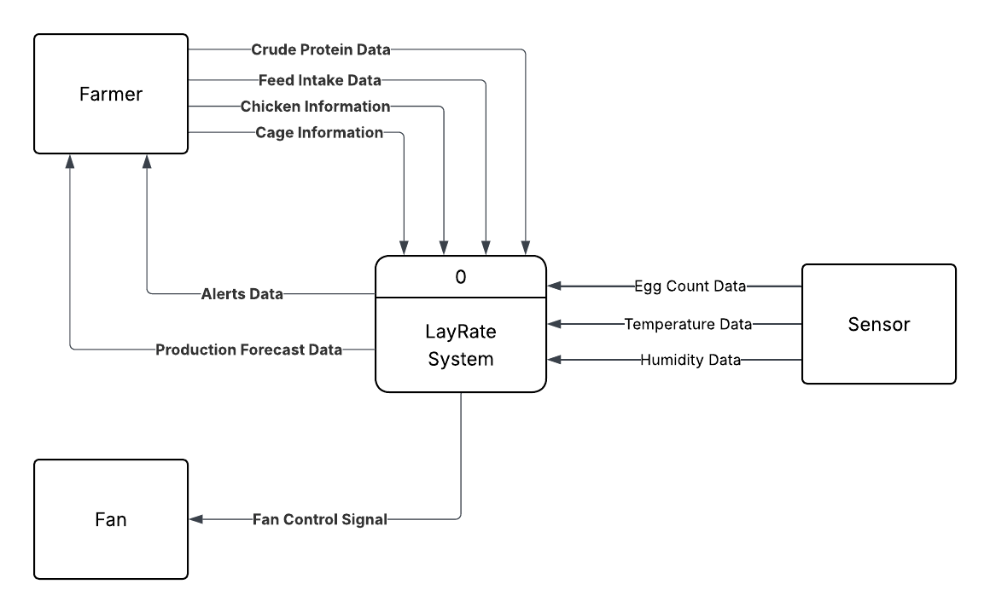
Context Diagram
Fig. 10 Context Diagram of LayRate
The Fig. 10 shows the context diagram of the LayRate system,illustrating the interaction between the external entities Farmer, Sensors, and Exhaust Fan with the system. The Farmer provides manual inputs including Feed Intake Data, Crude Protein Data, Hen Detail, and Cage Detail, while the Sensors automatically transmit Egg Count Data, Temperature Data, and Humidity Data. The system processes these inputs and delivers outputs to the Farmer in the form of Alert Data, Production Forecast Data, and Egg Production Data to support data-driven management decisions. Additionally, when environmental thresholds are exceeded, the system generates a Fan Control Signal directed to the Exhaust Fan, enabling automated temperature regulation within the poultry coop.
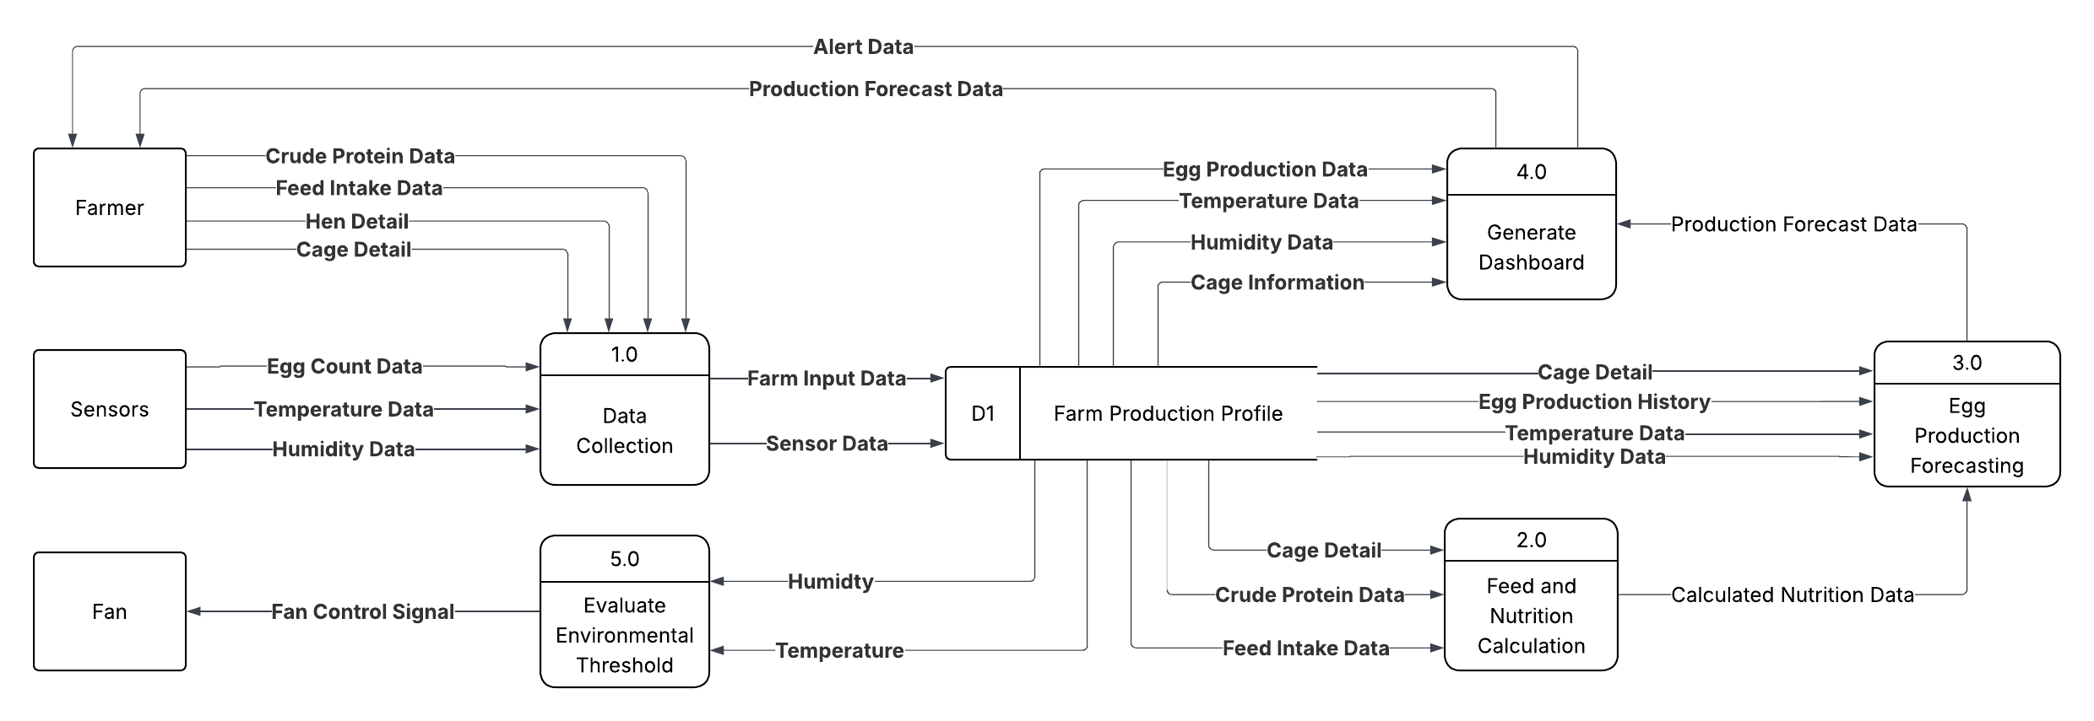
Data Flow Diagram
Fig. 11 Data Flow Diagram of LayRate
The Fig. 11 above shows the Data Flow Diagram of the LayRate system, illustrating the interaction among the external entities Farmer, Sensors, and Fan with the system. The diagram outlines five core processes: Data Collection, Feed and Nutrition Calculation, Egg Production Forecasting, Generate Dashboard, and Evaluate Environmental Thresholds. Inputs from the farmer—including Feed Intake Data, Crude Protein Data, Hen Detail, and Cage Detail—along with sensor readings for Egg Count Data, Temperature Data, and Humidity Data, are consolidated and stored in the Farm Production Profile. The stored data is subsequently processed to generate Calculated Nutrition Data and production forecasts. These results, along with Alert Data, are formatted and presented to the farmer through the monitoring dashboard to support data-driven management. Additionally, Temperature Data and Humidity Data are continuously evaluated against configured thresholds; when limits are breached, the system generates a Fan Control Signal directed to the Fan, enabling automated environmental regulation within the poultry coop.
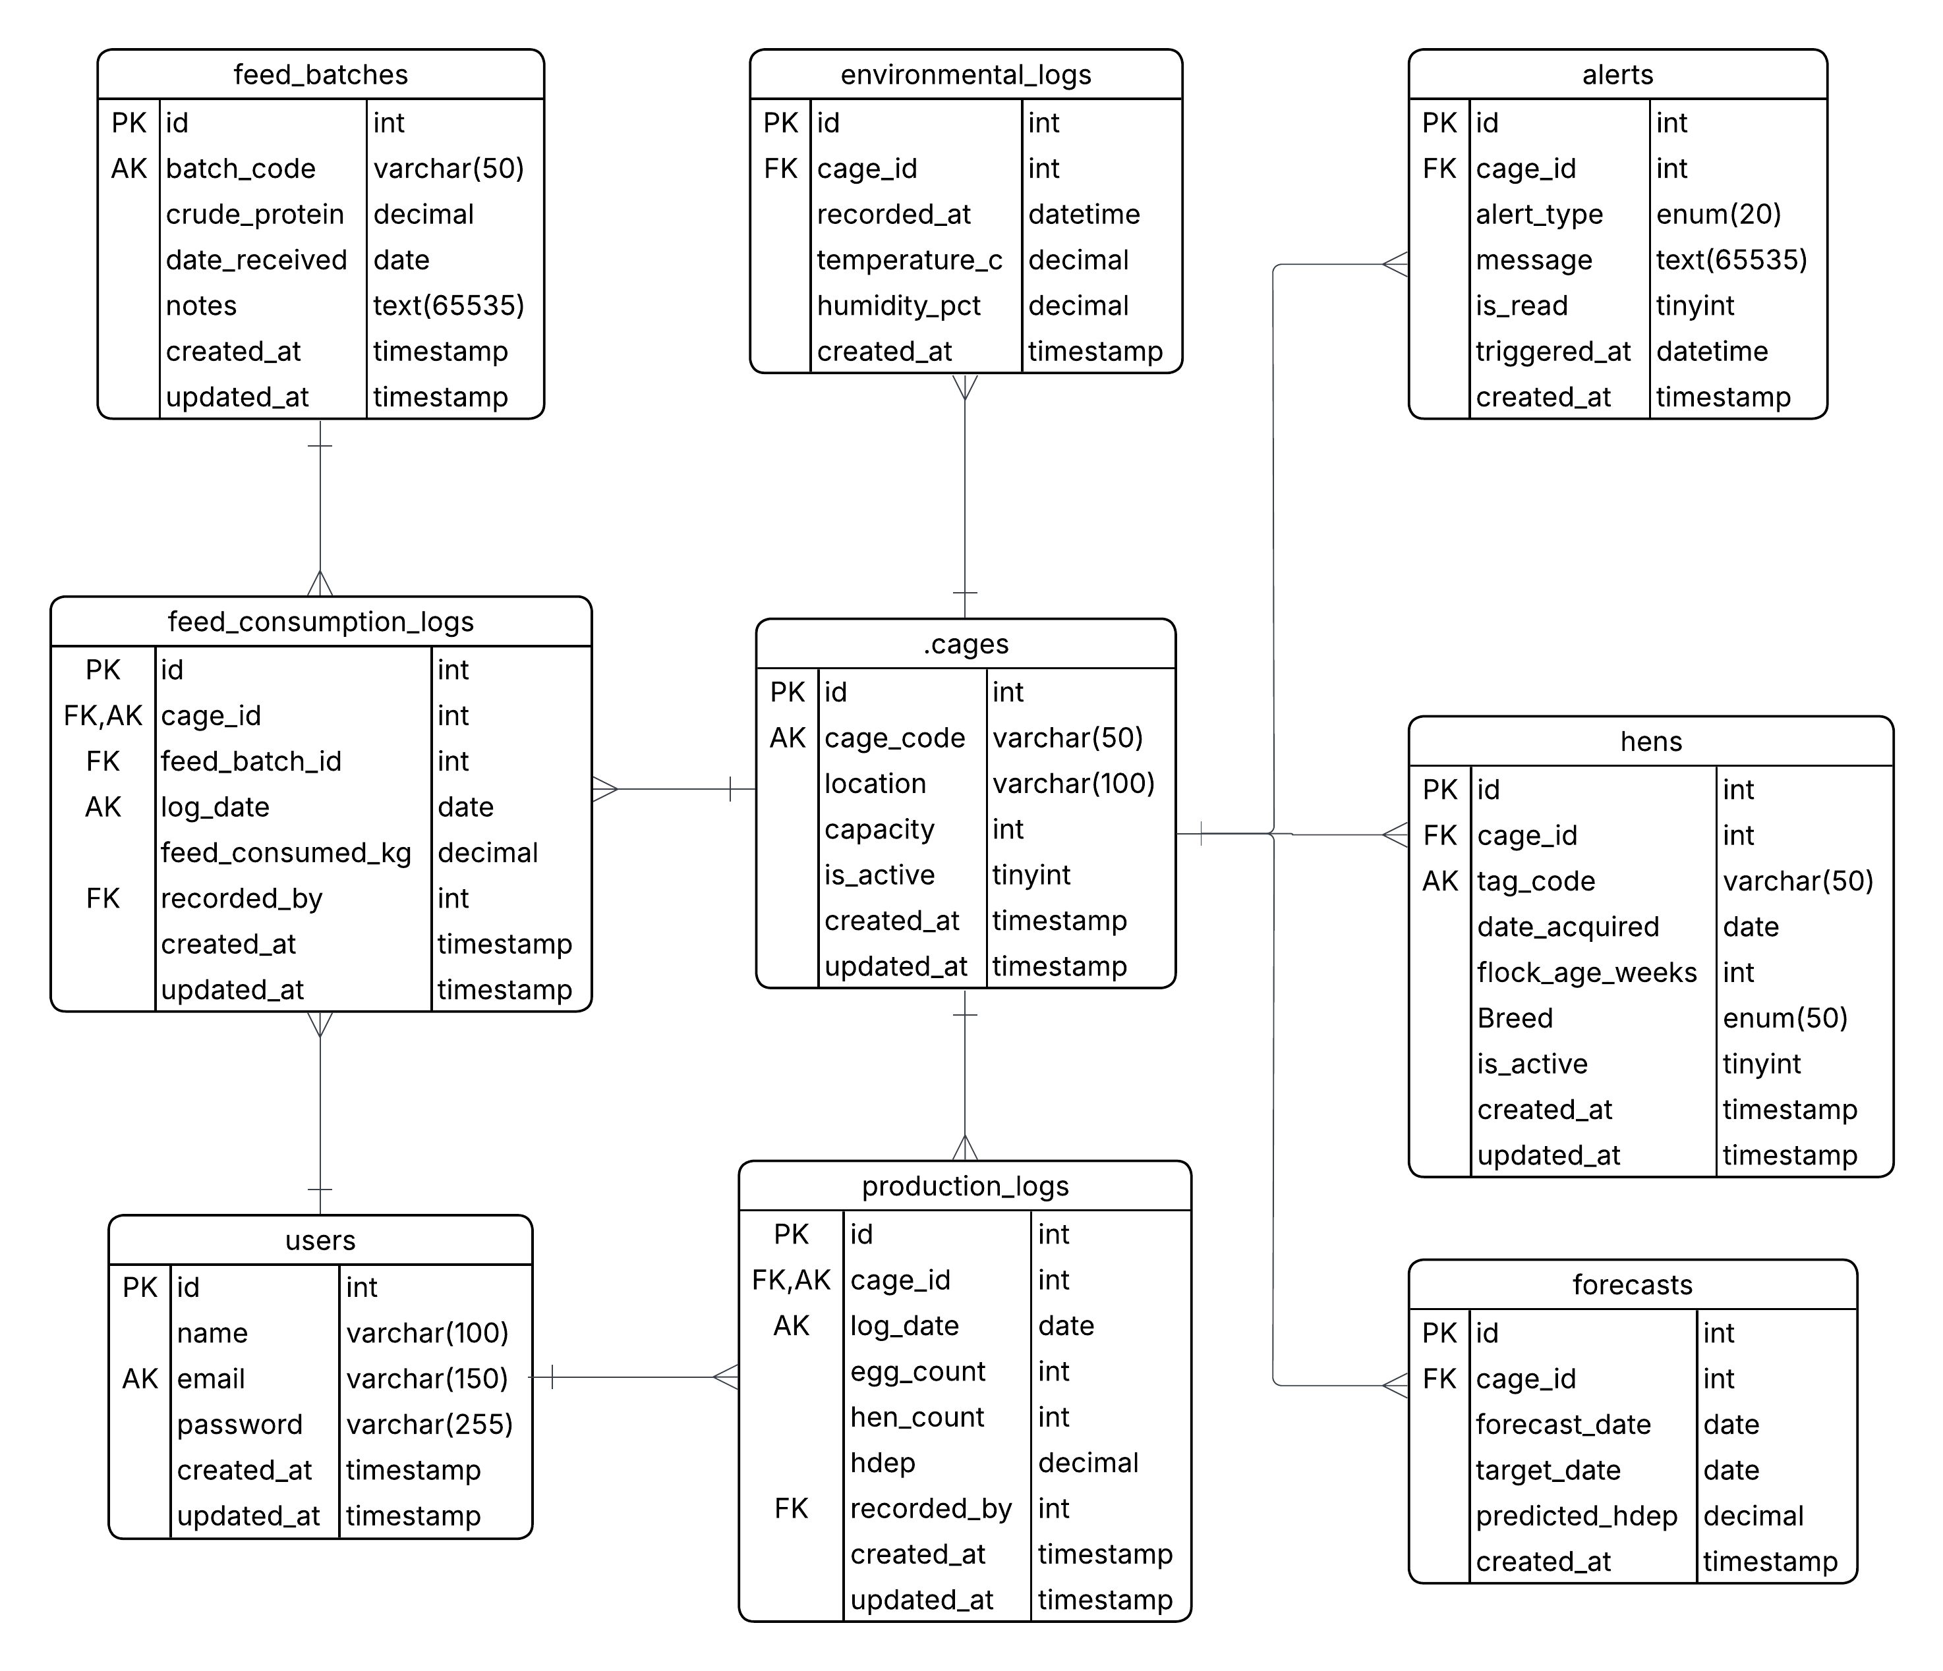
Entity Relationship Diagram
Fig. 12 Entity Relationship Diagram
Fig 12. shows the database structure of LayRate: An Offline Embedded Web-Based Monitoring and Forecasting System for Layer Chicken Egg Production. The system will be built around the central cages table, which will serve as the primary reference point for all farm operations. Each cage record will link to hens for inventory tracking, environmental_logs for continuous temperature and humidity readings collected by the Arduino-based sensors, and alerts for automated notifications triggered by abnormal production or environmental conditions. The production_logs table will record the daily egg count and hen count per cage, from which the system will automatically compute the Hen-Day Egg Production (HDEP) rate, while the forecasts table will store the predicted HDEP values generated by the XGBoost and SARIMA forecasting models. Feed management will be handled through two related tables: feed_batches, which will store each feed batch and its crude protein content, and feed_consumption_logs, which will record the daily feed intake per cage referencing both the cage and the feed batch used. The users table will manage system access, with both Admin and Operator roles linked to production and feed consumption logs through the recorded_by field to maintain accountability for every entry.
This organized database structure will ensure efficient handling of egg production monitoring, nutritional input tracking, environmental data logging, automated alert generation, and machine learning-based forecasting within a fully offline, locally deployed system.

SOFTWARE AND HARDWARE NEEDED IN THE DEVELOPMENT

Software Requirements
TABLE I.
Software Needed in the Development
Software | Description | Specification | Recommended Specifications
HTML, CSS, Bootstrap | Structures and styles the web-based dashboard interface | Frontend Structure and Design Tools | Latest stable release of Bootstrap 5.x; Chrome 110+ or Firefox 110+ for full CSS feature support
JavaScript | Adds interactivity and dynamic chart rendering to the dashboard | Client-Side Scripting Language | Latest stable browser (Chrome 110+, Firefox 110+, or Safari 16+) for full ES2022 support
PHP (Laravel Framework) | Handles backend processing, routing, authentication, and server-side logic | Server-Side Programming Language via Laravel MVC Framework | PHP 8.2+; 8 GB RAM; quad-core 2.5 GHz processor; 10 GB free disk space; Composer 2.x
Python | Implements the XGBoost and SARIMA forecasting module on the Raspberry Pi | Version 3.x, with scikit-learn, XGBoost, and statsmodels libraries | Python 3.10+; 8 GB RAM; 5 GB free disk space; scikit-learn 1.3+, XGBoost 2.0+, statsmodels 0.14+
MySQL | Stores all production, environmental, feed, mortality, and breed records locally | Relational Database Management System | MySQL 8.0+; 4 GB RAM; quad-core 2.0 GHz processor; 20 GB free disk space; InnoDB storage engine
XAMPP | Provides the local development environment during development and testing | Local Development Package (Apache + MySQL + PHP) | Windows 10 64-bit / Ubuntu 22.04; 4 GB RAM; 5 GB free disk space; XAMPP 8.2+ with PHP 8.2
Raspberry Pi OS | Operating system supporting the deployed web app, database, and forecasting module | Debian-based Linux operating system for Raspberry Pi | Raspberry Pi OS (64-bit) Bookworm; 32 GB Class 10 microSD; 4 GB RAM (Raspberry Pi 4 Model B)
Arduino IDE | Used to write and upload embedded firmware to the Arduino Uno R3 | Version 2.x, C++ with Arduino libraries | Arduino IDE 2.3+; 4 GB RAM; 2 GB free disk space; Java 17+; USB 3.0 port
Git | Manages version-controlled development and synchronization with the Raspberry Pi | Version Control System | Git 2.40+; 4 GB RAM; SSH access configured for secure Raspberry Pi synchronization
hostapd & dnsmasq | Configures the Raspberry Pi as a wireless access point for local network access | Access Point and DNS/DHCP Configuration Tools for Raspberry Pi OS | Raspberry Pi OS (64-bit Bookworm); hostapd 2.10+; dnsmasq 2.89+; Raspberry Pi 4 built-in 802.11ac Wi-Fi

Table I describes the software requirements necessary for LayRate to function as a fully offline, embedded web-based monitoring and forecasting system. A 64-bit operating system is strongly recommended for the development workstation. PHP through the Laravel framework will serve as the primary server-side programming language for the web application, integrated with MySQL for structured database management. Python will handle all machine learning forecasting operations locally on the Raspberry Pi 4 Model B, ensuring that XGBoost and SARIMA models execute without requiring cloud infrastructure or internet connectivity. The Arduino IDE will support the programming of the embedded firmware responsible for real-time sensor data acquisition within the Layer Hen farm environment. Additionally, hostapd and dnsmasq will be configured on the Raspberry Pi OS to enable it to function as a wireless access point, allowing farm operator devices to connect directly to the LayRate dashboard through the Raspberry Pi’s own hosted local network without dependence on any external router or internet service.

Hardware Requirements
Table II.
Hardware Needed in the Development
Hardware | Description | Specification
Computer System | Primary machine used by the developers for writing code, running the local server, and testing the system | Minimum: Intel Core i5 / AMD Ryzen 5 (2.5 GHz), 8 GB RAM, 256 GB SSD, 64-bit OS. Recommended: Intel Core i7 / AMD Ryzen 7 (3.5 GHz+), 16 GB RAM, 512 GB SSD, 64-bit Windows 10/11 or Ubuntu 22.04. Basis: Python ML training (XGBoost + SARIMA) running alongside Laravel and XAMPP/MySQL imposes the highest combined resource demand across all development software.
Mobile Phone | Device used to verify the system's layout and functionality on smaller screens across different mobile platforms | Minimum: Android 10 / iOS 14, 4 GB RAM, 720p display. Recommended: Android 12+ / iOS 16+, 6 GB RAM, 1080p display, Chrome or Safari latest stable
Raspberry Pi 4 Model B | Local server and network host for the offline LayRate system | Quad-core Cortex-A72 (ARM v8) 1.8 GHz, 4 GB LPDDR4 RAM, running Raspberry Pi OS (64-bit Bookworm), 802.11ac Wi-Fi
Arduino Uno R3 | Collects temperature, humidity, and egg count data from sensors | ATmega328P microcontroller at 16 MHz, 14 digital I/O pins (6 PWM), 32 KB Flash, 2 KB SRAM, USB-B interface
DHT22 Sensor | Measures temperature and humidity inside the Layer Hen housing | Temperature range: -40°C to 80°C (±0.5°C accuracy); Humidity range: 0–100% RH (±2–5% accuracy); 3.3V–5V operating voltage
IR Break Beam Sensor | Automatically detects and counts eggs at the designated collection point | Infrared emitter/receiver pair; 3.3V–5V operating voltage; detection range up to 25 cm; response time <1 ms
Relay Module | Interface between the Arduino Uno R3 and the fan; switches it ON/OFF based on temperature signals, enabling safe low-power control of a high-current device. | 5V single-channel relay module; 10A 250VAC / 10A 30VDC contact rating; compatible with Arduino Uno R3 5V logic output.
Cooling Fan | Actuator of the automated environmental control subsystem. It lowers coop temperature when triggered by the relay after exceeding the set threshold, helping prevent heat stress without manual intervention. | 12V DC brushless fan; CFM rating appropriate for coop volume; powered via relay module controlled by Arduino Uno R3.
MicroSD Card | Stores the Raspberry Pi OS, web application, database, and forecasting files | Minimum: 32 GB, Class 10 (A1 rated). Recommended: 64 GB, UHS-I / Class 10 (A2 rated) for improved I/O performance under concurrent database writes
Computer System | Primary machine used by the developers for writing code, running the local server, and testing the system | Minimum: Intel Core i5 / AMD Ryzen 5 (2.5 GHz), 8 GB RAM, 256 GB SSD, 64-bit OS. Recommended: Intel Core i7 / AMD Ryzen 7 (3.5 GHz+), 16 GB RAM, 512 GB SSD, 64-bit Windows 10/11 or Ubuntu 22.04. Basis: Python ML training (XGBoost + SARIMA) running alongside Laravel and XAMPP/MySQL imposes the highest combined resource demand across all development software.
Mobile Phone | Device used to verify the system's layout and functionality on smaller screens across different mobile platforms | Minimum: Android 10 / iOS 14, 4 GB RAM, 720p display. Recommended: Android 12+ / iOS 16+, 6 GB RAM, 1080p display, Chrome or Safari latest stable
Raspberry Pi 4 Model B | Local server and network host for the offline LayRate system | Quad-core Cortex-A72 (ARM v8) 1.8 GHz, 4 GB LPDDR4 RAM, running Raspberry Pi OS (64-bit Bookworm), 802.11ac Wi-Fi
The hardware listed above will ensure that LayRate operates efficiently during development, testing, and implementation. The development unit will serve as the primary workstation for programming both the embedded firmware and the web application, while the Raspberry Pi 4 Model B will function as the deployed local server within the farm environment. Critically, the Raspberry Pi 4 Model B will also serve as the local network host, enabling farm operator devices to access the LayRate web-based dashboard through their browser connected to its hosted local network, with no dependence on external internet connectivity. The Arduino Uno R3 and its connected sensors will handle all physical data acquisition within the Layer Hen housing environment.

INSTRUMENTATION
This study will utilize a technical evaluation approach to assess the performance, accuracy, and functionality of LayRate, an offline web-based layer farm monitoring and forecasting system that is going to be hosted on a Raspberry Pi. The researchers will adapt a descriptive-developmental research design wherein the system is goint to be evaluated using industry-standard benchmarking tools, automated testing frameworks, and established regression evaluation metrics. This approach was selected to provide objective, reproducible, and measurable data that accurately reflects the system's capabilities under controlled conditions, directly addressing the two primary evaluation objectives of the study: the functional correctness of the sensor data collection pipeline and machine learning forecasting models, and the performance of the system in terms of response time, throughput, scalability, and reliability under load.
The development of LayRate will follow an Agile iterative methodology, wherein the system is going to be built, tested, and refined in incremental stages. Each iteration focused on a specific set of system features, from Arduino-to-Raspberry Pi data transmission and sensor calibration to the training and validation of the XGBoost regression and SARIMA forecasting models, allowing the researchers to identify and resolve issues before proceeding to the next development phase. The evaluation phase will employ a structured benchmarking process to systematically measure the system's performance across all key quality attributes identified in the statement of the objectives.
The evaluation of LayRate will be conducted using a combination of performance benchmarking tools, automated functional testing frameworks, and forecasting accuracy metrics. The researchers will use these instruments to collect quantitative data that directly address the objectives of the study. Each tool is selected based on its relevance to a specific system quality attribute and its wide acceptance in software performance evaluation and machine learning literature.
TABLE III.
Benchmarking Tools and Corresponding Metrics per Evaluation Area
Evaluation Area | Benchmarking Tool | Metric Measured | Output
ML Forecast Accuracy (XGBoost & SARIMA) | Python Evaluation Scripts + Ground Truth Dataset | MAE, RMSE, MAPE per forecasting model | Accuracy Report
Sensor Data Accuracy | Arduino Serial Monitor + Manual Calibration Records | Mean Absolute Error vs. Reference Sensor (°C / %RH) | Calibration Report
Response Time | Apache JMeter | Average Response Time (ms) | Performance Report
Throughput | Apache JMeter | Requests per Second (RPS) | Throughput Report
Scalability | Apache JMeter (Ramp-Up Test Plan) | Degradation Rate under Increasing Load | Scalability Report
Reliability under Load | Apache JMeter | Error Rate (%), Uptime under Stress | Stability Report
Functional Correctness (UI) | Selenium / Playwright | Pass / Fail per System Feature | Functional Test Report
API Endpoint Correctness | Postman | HTTP Status Codes, Response Body Accuracy | API Test Report

Table III presents the mapping of each system evaluation area to its corresponding benchmarking tool and the metric used to measure it. This structured approach ensures that every aspect of LayRate's performance and functional correctness will be evaluated using the most appropriate and reliable instrument.
The tools and their specific roles in the evaluation of LayRate are described in detail in the succeeding sections.
Apache JMeter
Apache JMeter is an open-source load and performance testing tool widely used in software engineering to simulate concurrent user requests and measure system response under various levels of load. In this study, JMeter will be used to evaluate LayRate in four performance dimensions: response time, throughput, scalability, and reliability under load. A total of four (4) separate JMeter test plans will be configured and executed, one for each performance dimension. For the response time and throughput tests, each plan will execute 100 HTTP requests per thread group iteration. The scalability ramp-up test will simulate five (5) progressive concurrency levels (1, 5, 10, 25, and 50 concurrent virtual users), with each level sustained for a minimum of 60 seconds before incrementing. The reliability under load test will sustain 50 concurrent virtual users over a 300-second stress duration to observe system stability. JMeter will automatically record average response times, request throughput in requests per second, error rates, and performance degradation metrics, which will subsequently be exported for statistical analysis.
Selenium / Playwright
Selenium and Playwright are browser-based automated testing frameworks used to verify the functional correctness of LayRate’s web interface. A total of twenty-four (24) automated functional test cases will be written and executed across the eight (8) major system features identified in Table IV, comprising approximately three (3) test cases per feature covering primary functionality, boundary conditions, and error handling. Test scripts will simulate real-world user interactions across all user roles of the system, including farm owners viewing real-time sensor readings per cage, accessing egg production forecasts, configuring alert thresholds, and generating historical production reports, as well as administrators managing user accounts and system settings. Each test case will be assigned a Pass or Fail result based on whether the system produced the expected output, providing a clear and measurable indicator of functional compliance across all major system features of LayRate.
Postman
Postman is a widely adopted API testing platform used to validate the correctness and reliability of application programming interfaces. Newman, the command-line companion to Postman, will be used to automate the execution of pre-defined API test collections within the evaluation pipeline. In this study, the researchers will create a total of thirty (30) API test cases organized into six (6) test collections, covering all available LayRate backend endpoints including sensor data ingestion, real-time data retrieval per cage, egg production forecast generation, alert threshold configuration, historical report generation, and user authentication. Each request will be evaluated based on the returned HTTP status codes, the accuracy of the response body, and the response time recorded by the tool. Each collection will be executed a minimum of three (3) times to confirm consistency of results across independent runs.
Ground Truth Dataset and Python Evaluation Scripts
To objectively measure the forecasting accuracy of LayRate’s machine learning models, the researchers will prepare a ground truth dataset consisting of a minimum of ninety (90) days of historical sensor records, breed data, and corresponding actual egg production counts collected from the layer cages during the data gathering phase of the study. This dataset will be split using an 80/20 train-test ratio, reserving approximately eighteen (18) days of complete daily records exclusively for evaluation purposes. Python evaluation scripts will submit each input sequence in the withheld test set to the trained XGBoost regression and SARIMA models and compare the predicted outputs against the actual ground truth values. The evaluation will be run three (3) independent times per model using different random seeds to ensure result stability, enabling the automated calculation of Mean Absolute Error (MAE), Root Mean Square Error (RMSE), and Mean Absolute Percentage Error (MAPE) for each model, thereby providing a reliable and unbiased assessment of forecasting accuracy.
Arduino Serial Monitor and Calibration Records
To validate the accuracy of the sensor data collected from the layer cages, the researchers will use the Arduino Serial Monitor together with calibration records obtained from reference instruments. Temperature and humidity readings captured by the DHT22 sensors connected to the Arduino microcontrollers will be compared against values recorded by calibrated reference sensors under identical environmental conditions. A total of thirty (30) paired sensor readings will be collected per sensor unit across three (3) calibration sessions conducted at different times of day (morning, midday, and afternoon) to account for diurnal environmental variation. The Mean Absolute Error between the LayRate sensor output and the reference readings will be computed for each sensor type to quantify measurement accuracy prior to integration into the Raspberry Pi data pipeline.
Evaluation Metrics and Formulas
The researchers will utilize several quantitative metrics to assess the performance and functional accuracy of LayRate. The formulas presented below will be applied to the data gathered through the benchmarking instruments described earlier. These metrics will collectively provide a comprehensive evaluation of the system’s effectiveness in delivering accurate, real-time, and efficient layer farm monitoring and egg production forecasting support.
ML Forecasting Accuracy: MAE, RMSE, and MAPE
The forecasting accuracy of LayRate's XGBoost regression and SARIMA models was evaluated using Mean Absolute Error (MAE), Root Mean Square Error (RMSE), and Mean Absolute Percentage Error (MAPE) computed against the withheld ground truth dataset. MAE measures the average magnitude of prediction errors without considering their direction. RMSE penalizes larger errors more heavily, providing a measure sensitive to outliers. MAPE expresses the average prediction error as a percentage of actual values, enabling intuitive interpretation of relative model performance.
MAE = (1/n) × Σ |yᵢ − ŷᵢ|
RMSE = √[(1/n) × Σ (yᵢ − ŷᵢ)²]
MAPE = (100/n) × Σ |( yᵢ − ŷᵢ) / yᵢ|
where:
  - yᵢ = will represent the actual egg production count at time step i
- ŷᵢ = Will represent the predicted egg production count at time step i
- n = will represent the total number of observations in the evaluation dataset
Average Response Time
The Average Response Time will be calculated to evaluate how quickly the system processes and returns results for key user interactions, including dashboard loading, forecast retrieval, and report generation. This metric will be recorded in milliseconds for each request during JMeter test execution.
Average Response Time = ΣResponse Time / N
where:
ΣResponse Time will represent the total of all recorded response times
N will represent the total number of requests submitted during testing

Throughput
Throughput will be measured to determine how many requests LayRate can successfully handle per unit of time under a specified load. This metric will reflect the system’s ability to support concurrent farm owner sessions during peak usage periods.
Throughput = Total Number of Requests / Total Test Duration (seconds)

Scalability
Scalability will be evaluated by observing how the system’s average response time will degrade as the number of concurrent users increases during the JMeter ramp-up test. The degradation rate will be computed to identify the concurrency threshold at which system performance exceeds acceptable limits.
Degradation Rate (%) = [(RTₙ − RT₁) / RT₁] × 100
where:
  - RTₙ = will represent the response time at the highest concurrency level
  - RT₁ = will represent the baseline response time at the lowest concurrency level
Reliability under Load
Reliability under load will be assessed by measuring the system’s error rate during sustained high-concurrency testing using Apache JMeter. This metric will indicate the proportion of failed requests relative to the total number of requests submitted.
Error Rate (%) = (Number of Failed Requests / Total Requests) × 100
A lower error rate will indicate higher system reliability. The researchers will set an acceptable threshold of less than five percent (5%) as the benchmark for satisfactory performance.

PREPARATION AND EVALUATION
The researchers will prepare the evaluation environment before executing benchmarking tests to ensure consistency and fairness across all scenarios. A structured set of test cases, benchmarking scripts, and evaluation datasets will be developed to serve as the primary tools for collecting quantitative data. This preparation will align with the research objectives to ensure that each test addresses a measurable problem.
The preparation phase will include the configuration of Apache JMeter test plans covering response time, throughput, scalability, and reliability, along with the setup of thread groups, ramp-up periods, and loop counts simulating realistic usage. Selenium and Playwright automation scripts will be developed to test system functionalities. A ground truth dataset will be constructed and validated for ML models, including historical sensor data and egg production records. Sensor calibration will be performed using reference instruments, and Postman collections will be prepared for backend API testing.
All benchmarking activities will be conducted in a controlled environment with consistent hardware and network conditions to reduce external influence.
The Raspberry Pi server will be maintained in a stable state throughout testing. Results will be automatically logged, exported, and processed using the defined formulas to compute final evaluation metrics. These results will provide an objective basis for assessing LayRate’s effectiveness as an offline, sensor-integrated monitoring and forecasting system.

TABLE IV.
System Functionality Evaluation Criteria for LayRate
System Feature | Evaluation Criterion | Test Output
Egg Production Forecasting (XGBoost & SARIMA) | Accurately forecasts egg output per cage based on historical sensor data | MAE / RMSE / MAPE per model
Sensor Data Collection Module | Correctly receives, parses, and stores temperature, humidity, and egg count data from Arduino; breed is recorded as a manually entered cage attribute | Pass / Fail per data ingestion test
Real-Time Monitoring Dashboard | Displays live and historical sensor readings per cage with correct values and timestamps | Pass / Fail per dashboard assertion
Alert and Threshold Notification | Triggers alerts when sensor values exceed configured thresholds | Pass / Fail per alert scenario
Historical Data & Report Generation | Generates accurate production reports filterable by cage, date, and metric | Pass / Fail + data accuracy check
Offline Web Interface (Raspberry Pi) | System remains fully functional without external internet connection when hosted on Raspberry Pi | Pass / Fail per offline scenario
Role-Based Access Control | Enforces correct access restrictions for Farm Owner and Administrator roles | Pass / Fail per role-access test
Arduino-to-Raspberry Pi Data Transfer | Data transmitted from Arduino is received and stored accurately by the Raspberry Pi server | Pass / Fail + transmission accuracy

Table V will present the functional evaluation criteria for each major feature of LayRate. Each criterion will define the expected system behavior required to achieve a passing result, while the test output column will specify how results will be recorded. These criteria will serve as the foundation for the automated test scripts developed during the preparation phase.
Performance Rating Scale
To standardize the interpretation of evaluation results, the researchers will adopt a five-point rating scale. This scale will be used to summarize overall system performance and provide descriptive interpretations for each range of computed metric values.
TABLE V.
Guideline Interval for Performance Rating Scale
Scale | Mean Range | Descriptive Equivalent
5 | 4.21 – 5.00 | Outstanding
4 | 3.41 – 4.20 | Very Satisfactory
3 | 2.61 – 3.40 | Satisfactory
2 | 1.81 – 2.60 | Needs Improvement
1 | 1.00 – 1.80 | Needs Redevelopment

Table IV presents the guideline intervals used to interpret the aggregated performance ratings for the level of effectiveness of the developed system. The table shows the corresponding descriptive equivalents for each mean range, from Outstanding to Needs Redevelopment. These intervals provide a standardized basis for evaluating system quality attributes, ensuring a consistent interpretation of the results. The guideline also supports identifying areas of strength and aspects that require improvement before the full deployment of LayRate on the layer farm.

ETHICAL CONSIDERATIONS
In conducting the proposed study, multiple ethical considerations will be observed to ensure compliance with data privacy, security, and research integrity. The researchers will strictly uphold the confidentiality of all farm production data and sensor records accessed during the development and evaluation of LayRate. All test data used in the benchmarking process will either be synthetically generated for evaluation purposes or sourced from actual layer farm records for which proper authorization will be secured from the farm owner. No personal data of any individual will be collected, processed, or disclosed beyond what is strictly necessary for system testing and validation.
Prior to the use of any data, the researchers will ensure that all activities comply with applicable institutional data governance policies and the provisions of the Data Privacy Act of 2012 (Republic Act No. 10173). All stored farm records within
LayRate will be protected through the system’s role-based authentication and access control mechanisms, ensuring that sensitive production data remains accessible only to authorized users. The integrity of the historical sensor dataset reserved for ground truth evaluation will be preserved to prevent contamination in the forecasting model assessment.
Furthermore, all algorithms, frameworks, and literature utilized in the development of LayRate will be properly acknowledged and attributed to their respective authors in accordance with academic integrity standards. In particular, the XGBoost algorithm developed by Chen and Guestrin [53] and the SARIMA time-series modeling framework introduced by Box and Jenkins [54] will be implemented in strict adherence to their publicly documented specifications. Collectively, these ethical measures will aim to establish LayRate as a reliable, secure, and academically responsible platform that protects the rights, privacy, and integrity of all farm stakeholders involved in the study.

REFERENCES
- A.N. Taer and E.C. Taer, "Harnessing Precision and Innovation: A Systematic Review of Precision Livestock Farming and IoT Technologies in the Philippines",Ceylon Journal of Science , Vol. 54, No. 1, pp. 53–64, 2025
- J. J. R. Yasay, "Internet of Things in the Philippine Agribusiness",International Journal of Advanced Research in Science Communication and Technology , Vol. 6, No. 1, pp. 518–525, 2021
- M. Cortez, "Investigating Young Filipino Farmers' Digital Technology Adoption", IEEE ICECCE 2024, pp. 1–6, 2024
- J.K.B. Rogers, F.T. Simpao, S.S. Villanueva, B.V. Salangsang, K.D. Andripa, "Development of IoT-Based Decision Support System for Environmental Monitoring in Poultry Houses", Science International (Lahore , Vol. 35, No. 5, pp. 633 - 638, 2023
- H. L. Soliman-Cuevas, "ZamPen Chick Monitoring using Wireless Sensor Network", 2024 Conference on Information Communications Technology and Society (ICTAS), pp. 1–6, 2024
- N. Bumanis, A. Kviesis, L. Paura, I. Arhipova, and M. Adjutovs, "Hen Egg Production Forecasting: Capabilities of Machine Learning Models in Scenarios with Limited Data Sets",Applied Sciences (MDPI) , Vol. 13, No. 13, pp. 1–15, 2023
- P. Panagi, S. Karatsiolis, K. Mosphilis, N. Hadjisavvas, A. Kamilaris, N. Nicolaou, E. Stavrakis, and V. Vassiliades, "Poultry Farm Intelligence: An Integrated Multi-Sensor AI Platform for Enhanced Welfare and Productivity",SSRN Electronic Journal (Preprint) , pp. 1–25, 2024
- X. Li, G. Zhao, J. Liu, S. Zhang, Y. Wang, and T. Wang, "Design of Intelligent Layer Farming System Based on Internet of Things + Artificial Intelligence Technology",pp. 174 - 179, 2025
- X. Yang, R.B. Bist, U. Paneru, J. Liu, E. Applegate, C. Ritz, W.K. Kim, P. Regmi, and L. Cha, "Computer Vision-Based Cybernetics Systems for Promoting Modern Poultry Farming: A Critical Review", Computers and Electronics in Agriculture , Vol. 225, Art. No. 109339, 2024
- M. Carraro, A. Pravato, F. Marinello, R. Bordignon, A. Trocino, G. Xiccato, and A. Pezzuolo, "A New Tool to Improve the Computation of Animal Kinetic Activity Indices in Precision Poultry Farming",Artificial Intelligence in Agriculture , Vol. 16, pp. 110–118, 2025
- R. Gong, H. Zhang, G. Li, and J. He, "Edge Computing-Enabled Smart Agriculture: Technical Architectures, Practical Evolution, and Bottleneck Breakthroughs",Sensors (MDPI) , Vol. 25, No. 17, Art. No. 5302, pp. 1–28, 2025
- Y. Lin, S. Chen, and Y. Chang, "Moving from Cloud to Fog/Edge: The Smart Agriculture Experience",IEEE Communications Magazine , Vol. 61, No. 3, pp. 86 - 92, 2023
- M. El Jarroudi, L. Kouadio, P. Delfosse, C.H. Bock, A.K. Mahlein, X. Fettweis, B. Mercatoris, F. Adams, J.M. Lenné, and S. Hamdioui, " Leveraging Edge Artificial Intelligence for Sustainable Agriculture",Nature Sustainability , Vol. 7, No. 7, pp. 846–854, 2024
- A. F. Ugpat, J. D. C. Ojeda, M. S. Bacus, A. S. Quijano-Pagutayao, V. B. Sarita, "Farming the Future: Review of Agricultural Extension's Role in Digital and Smart Farming Technologies in Davao Oriental, Philippines", International Journal of Research and Scientific Innovation (IJRSI) , Vol. 12, No. 5, pp. 319–337, 2025
- M. A. D. Perin; L. S. Feliscuzo, "A Prototype of Project M.A.K.A.S.A. (Modeling Agricultural Knowledge with A.I. for Sustainable Agriculture): An Intelligent Information System", 2024 7th International Conference on Data Science and Information Technology (DSIT), pp. 58–63, 2024
- R.V. Villanueva, H.S. Hwang, and K.S. Choi, "The Philippine Livestock Industry: A Review of Current Status, Key Challenges, Emerging Opportunities, and Sustainable Growth Strategies in a Developing Country Context",International Journal of Developing Country Studies (IJDCS) , Vol. 7, No. 3, pp. 1–26, 2025
- A.M. Monleon, "Futures of Livestock Industry from the Viewpoints of Jurisprudence and Regulatory Measures in the Philippines", pp. 1-21, 2024
- C.A. Gerez, M.B. Barquilla, V.B. Zabala, K.M.M.D. Casas, and C.T. Dumadag, "Naturally Formulated Chicken Feeds for Sustainable Poultry Farming in Iligan City, Philippines", International Journal of Research and Innovation in Social Science (IJRISS) , Vol. 9, No. 6, pp. 2896–2905, 2025
- Lohmann Breeders, "Management Guide: Lohmann Brown-Classic Layers – Cage Housing",2024
- Institut de Sélection Animale B.V. (ISA), "Dekalb White Product Guide: Cage Production System",2022
- Institut de Sélection Animale B.V. (ISA), "ISA Brown Commercial Layers: Product Guide Cage – Southeast Asia", 2024
- R.C. Maaño, R.A. Maaño, P.J.L. De Castro, E.P. Chavez, S.C. De Castro, and C.D. Maligalig, "Title: SmartHatch: An Internet of Things–Based Temperature and Humidity Monitoring System for Poultry Egg Incubation and Hatchability", 2023 International Conference on Information Technology and Engineering (ICITE), pp. 1–4, 2023
- U. V. Ramizares, W. J. A. Teves, E. R. Arboleda, and J. M. C. Bangeles, "Intelligent temperature-controlled poultry feed dispensing system with fuzzy logic algorithm",International Journal of Robotics and Control Systems , Vol. 4 No. 1, pp. 69 - 87, 2024
- W. B. Sabado, "Acceptability of the layer poultry farm management system",International Journal of Computing Sciences Research , Vol. 8, pp. 2580–2591, 2024
- L. C. F. Simon and T. D. Palaoag, "Prototype of Smart Poultry for Small-Scale Poultry Farmers at Ilocos Norte",International Journal of Research and Scientific Innovation , Vol. 11, No. 5, pp. 442-450, 2024
- S. Jebari, J. Mechkouri, and B. Rekiek, et al., "Poultry-Edge-AI-IoT System for Real-Time Monitoring and Predicting by Using Artificial Intelligence", International Journal of Interactive Mobile Technologies (iJIM) , Vol. 17, No. 12, pp. 149–170, 2023
- F. Hanau, D. Lopes, and L. Santos, et al., "Smart Farming for Poultry: Leveraging Chicken Raising with Low-Cost IoT-based Information Systems", Anais do XXI Simpósio Brasileiro de Sistemas de Informação (SBSI), pp. 1–6, 2025
- R.O. Ojo, A.O. Ajayi, H.A. Owolabi, L.O. Oyedele, and L.A. Akanbi, " Internet of Things and Machine Learning techniques in poultry health and welfare management: A systematic literature review",Computers and Electronics in Agriculture , Vol. 200, Art. No. 107266, 2022
- A.A. Okubanjo, I.K. Okakwu, O.P. Alao, N.S. Lawal, A.A. Babalola, and A. Olayiwola, "Sustainable poultry farming: A concept of IoT-based poultry management system for small-scale farmers",Al-Bahir Journal for Engineering and Pure Sciences , Vol. 3, No. 4, pp. 111-132, 2024
- Y.J. Heo, J. Park, Y.B. Kim, B.Y. Kwon, D.H. Kim, J.Y. Song, and K.W. Lee, "Effects of Dietary Protein Levels on Performance, Nitrogen Excretion, and Odor Emission of Growing Pullets and Laying Hens",Poultry Science , Vol. 102, No. 4, Art. No. 102642, 2023
- I. P. T. Da Nóbrega, M. de P. Reis, F. A. H. Morillo, L. F. V.-B. De Freitas, L. C. Bittencourt, J. B. K. Fernandes, and N. K. Sakomura, "Dynamics of Growth and Egg Traits in Three Dietary Balanced Protein Scenarios Applied for Laying Hens",Animals , Vol. 12, No. 11, Art. No. 1371 (pp. 1–17), 2022
- I. P. T. da Nóbrega, M. de P. Reis, R. R. Lizana, T. F. de Moura, G. F. da S. Teofilo, L. C. Bittencourt, and N. K. Sakomura, "Response of Laying Hens to Repletion and Depletion in Dietary Balanced Protein",Animals , Vol. 12, No. 19, Art. No. 2567 (pp. 1–19), 2022
- W. D. Lee, K. Kothari, J. Kim, K. I. Kim, G. W. Ga, Y. G. Kim, H. J. Kim, and H. K. Kang, "Effects of Energy and Protein Levels on Laying Performance, Egg Quality, Blood Parameters, Blood Biochemistry, and Apparent Total Tract Digestibility on Laying Hens in an Aviary System",Animals , Vol. 12, No. 24, Art. No. 3513 (pp. 1–16), 2022
- S. J. Wilkinson, A. F. Moss, T. M. Crowley, and M. J. Zuidhof, "Effects of AM/PM Diets on Laying Performance, Egg Quality, and Nutrient Utilisation in Free-Range Laying Hens",Applied Sciences , Vol. 14, No. 5, Art. No. 2163 (pp. 1–17), 2024
- C. Wu, X. Li, J. Fan, Z. Ma, Q. Zhu, T. Dou, and L. Liu, "Integrated Assessment of Productive, Environmental, and Social Performances of Adopting Low-Protein Diets Technology for Laying Hens",Animals , Vol. 15, No. 2, Art. No. 146 (pp. 1–17), 2025
- Y. Li, R. Ma, R. Qi, J. Li, W. Liu, Y. Wan, S. Li, Z. Sun, J. Xu, and K. Zhan, "Novel Insight into the Feed Conversion Ratio in Laying Hens and Construction of Its Prediction Model",Poultry Science , Vol. 103, No. 9, Art. No. 104013, 2024
- R. Wu, P. He, Y. He, J. Dou, M. Di, S. He, K. Hayat, J. Pan, and H. Lin, "Egg Production Monitoring in Commercial Laying Cages Via Strongsort-Egg Tracking-by-Detection Model", Art. No. 109508, 2024
- H. Ji, Y. Xu, and G. Teng, "Predicting Egg Production Rate and Egg Weight of Broiler Breeders Based on Machine Learning and Shapley Additive Explanations",Poultry Science , Vol. 104, No. 2, Art. No. 104458, 2025
- W. Morales-Suárez, L. D. Daza, and H. A. Váquiro, "Artificial Neural Networks for Modeling and Optimizing Egg Cost in Second-Cycle Laying Hens Based on Dietary Intakes of Essential Amino Acids",AgriEngineering , Vol. 5, No. 4, pp. 1912–1928, 2023
- C. Lukito, R. B. Lukito, E. Ernawati, "Implementation of IoT Edge Computing for Control and Monitoring System of Hydroponic Plant Water Quality Using Raspberry Pi",International Journal of Computer Science and Human-Animal Interaction , Vol. 1, No. 1, pp. 25-32, 2024
- Peng Liu, X. Cao, and Y. Jia, "Performance Evaluation and Analysis of Scalable Raspberry Pi 4 Model B Clusters", pp. 1-18, 2024
- A. V. Deshpande et al., "Harnessing the Potential of Raspberry Pi 4 Model B in Smart IoT Ecosystems", International Research Journal of Modernization in Engineering Technology and Science , Vol. 6, No. 5, pp. 5865–5870, 2025
- C. M. Wathes, H. H. Kristensen, J.-M. Aerts, D. Berckmans, "Is precision livestock farming an engineer’s daydream or nightmare, an animal’s friend or foe, and a farmer’s panacea or pitfall?",Computers and Electronics in Agriculture , Vol. 64, No. 1, pp. 2–10, 2008
- D. Berckmans, "General introduction to precision livestock farming",Animal Frontiers , Vol. 7, No. 1, pp. 6–11, 2017
- National Research Council (NRC), "Nutrient Requirements of Poultry: Ninth Revised Edition, 1994", pp. 1–176, 1994
- S. Leeson and J. D. Summers, "Commercial Poultry Nutrition (3rd Edition)", pp. 1–398, 2009
- A. Pérez-Bonilla, C. Jabbour, M. Frikha, S. Mirzaie, J. Garcia, and G. G. Mateos, "Effect of crude protein and fat content of diet on productive performance and egg quality traits of brown egg-laying hens with different initial body weight",Poultry Science , Vol. 91, No. 6, pp. 1400–1405, 2012
- Bureau of Animal Industry (BAI), Department of Agriculture (DA), "Philippine Poultry Layer Industry Roadmap 2022–2040", 2022
- Philippine Statistics Authority (PSA), "Chicken Egg Situation Report", 2025
- Jim Highsmith, "Agile Project Management: Creating Innovative Products", 2004
- Chen, Tianqi and Guestrin, Carlos, " XGBoost: A Scalable Tree Boosting System", ACM, 785–794, 2016
- Box, George E. P. and Jenkins, Gwilym M. and Reinsel, Gregory C. and Ljung, Greta M., "Time Series Analysis: Forecasting and Control",Wiley , 2015

